CSS BRITISH HISTORY · TOPIC 7 · KNOWLEDGE BASE
Edwardian Britain, the Great War and the Road to 1939
From the death of Queen Victoria to the outbreak of the Second World War — the Edwardian age, the Liberal reforms, the rise of Labour, the First World War and its effects, the peace settlement, the League of Nations, the Depression and appeasement, with the story carried on to 2026

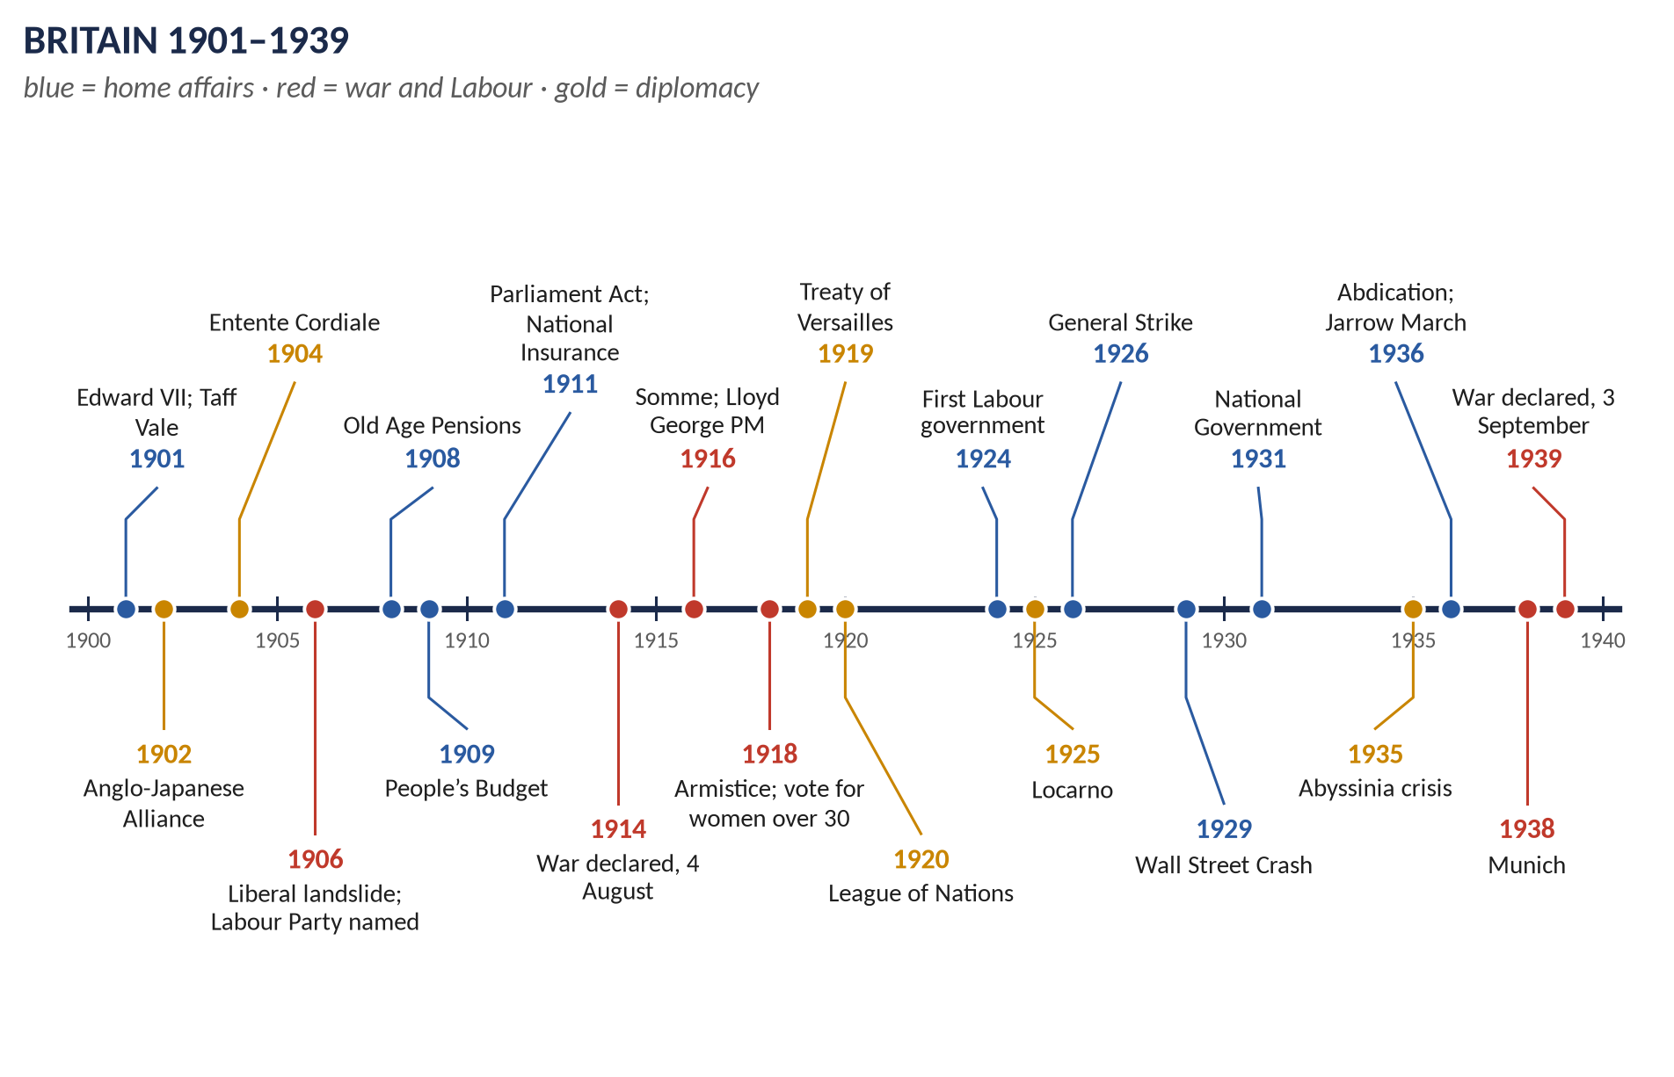
Syllabus heads X and XI. 8 past items in 2015–2026 — the Labour movement 2, the First World War 3, Kitchener (short note), interwar foreign policy and the League of Nations — and 6 MCQs. Told from zero, then ten chapters covering the whole of both heads, with 120 one-liners and a stand-alone revision sheet.
Topic 7 of 10 · read with the companion document T7QA
Contents
HOW TO USE THIS · Updating the contents
Right-click the contents → Update Field → Update entire table, before saving as PDF.

How to Use This Document 7
What this Topic covers 7
Part Zero — The ABC Before the Story 8
0.1 Britain in 1901 — the simple picture 8
0.2 The words you need 8
Part One — The Story 10
1.1 The Edwardian age (1901–1910) 10
1.2 The Liberal reforms (1906–1914) 10
1.3 Crisis years (1910–1914) 10
1.4 The First World War (1914–1918) 10
1.5 Peace and the League (1919–1929) 11
1.6 Britain between the wars (1918–1939) 11
1.7 The road to war (1931–1939) 11
Part Two — The Cast and the Time-line 12
2.1 The cast 12
2.2 The time-line 13
Part Three — The Chapters 14
Chapter 1 · The Edwardian Era, 1901–1914 15
1.1 What was the "Edwardian era"? 15
1.2 Edward VII 15
1.3 Edwardian society 15
1.4 Conservative government (1901–1905) 15
1.5 The general election of 1906 16
1.6 The Liberal reforms (1906–1914) 16
(i) Why the Liberals introduced reforms 17
(ii) Children 17
(iii) The old 17
(iv) Workers 17
(v) The People's Budget (1909) 17
(vi) The constitutional crisis and the Parliament Act (1909–1911) 18
(vii) National Insurance Act (1911) 18
(viii) Assessing the reforms 18
1.7 The great crises (1910–1914) 18
1.8 Edwardian foreign policy (1901–1914) 19
Chapter 2 · The Rise of the Labour Movement and the Labour Party 20
2.1 What was the Labour movement? 20
2.2 The roots (before 1900) 20
(i) Trade unions 20
(ii) Socialist societies 20
(iii) Working men in Parliament 20
2.3 The Labour Representation Committee (1900) 20
2.4 The Edwardian breakthrough (1901–1914) 21
2.5 The significance of the Edwardian Labour movement 21
2.6 The war and the new party (1914–1918) 21
2.7 Labour between the wars (1918–1939) 22
2.8 Labour in power — the achievements (1940–2026) 23
(i) The wartime coalition (1940–45) 23
(ii) The Attlee government (1945–51) — the great achievements 23
(iii) Later Labour governments 23
Chapter 3 · The Causes of the First World War 25
3.1 The long-term causes — "M·A·I·N" 25
(i) Militarism 25
(ii) Alliances 25
(iii) Imperialism 25
(iv) Nationalism 26
3.2 The crises (1905–1913) 26
3.3 The July Crisis (1914) 26
3.4 Why Britain went to war 26
3.5 Who was to blame? — the historians 27
Chapter 4 · Britain in the First World War, 1914–1918 28
4.1 The course of the war — in brief 28
4.2 Government and politics in the war 29
4.3 The home front 29
4.4 Lord Kitchener (1850–1916) 29
(i) The imperial soldier 29
(ii) The war minister (1914–16) 30
4.5 Was British policy in the war justified? — the issues 30
Chapter 5 · The Effects of the First World War on Britain 31
5.1 Human cost 31
5.2 Economic effects 31
5.3 Social effects 32
5.4 Effects on industrial relations 32
5.5 Effects on the polity 32
5.6 How the war accelerated the decline of the Liberal Party 33
(i) Before the war — was the Liberal Party already dying? 33
(ii) How the war hurt the Liberals 33
(iii) How the war paved the way for Labour 33
Chapter 6 · The Peace Settlement, 1919–1923 35
6.1 The Paris Peace Conference (January–June 1919) 35
6.2 The Treaty of Versailles (28 June 1919) 35
(i) Territory 35
(ii) Military 36
(iii) Guilt and reparations 36
(iv) The League 36
6.3 The other treaties 36
6.4 Britain and the settlement 36
6.5 Judging the settlement 36
Chapter 7 · The League of Nations, 1920–1946 38
7.1 Origins and aims 38
7.2 Structure 38
7.3 The work of the League 39
(i) Political successes 39
(ii) Humanitarian successes 39
(iii) Failures 39
7.4 Why the League failed 40
Chapter 8 · British Foreign Policy, 1919–1939 41
8.1 Britain's aims and position 41
8.2 Phase 1 · 1919–1923: making and defending the settlement 41
8.3 Phase 2 · 1924–1929: conciliation — "the spirit of Locarno" 41
8.4 Phase 3 · 1929–1935: depression and disarmament 41
8.5 Phase 4 · 1935–1938: appeasement 42
8.6 Phase 5 · 1939: from appeasement to war 43
8.7 Rearmament 43
8.8 Was appeasement right? — the debate 43
Chapter 9 · Britain at Home Between the Wars, 1918–1939 45
9.1 The Lloyd George coalition (1918–1922) 45
9.2 The 1920s 45
9.3 The Great Depression (1929–1933) 45
9.4 Two Britains 46
9.5 The abdication crisis (1936) 46
9.6 Neville Chamberlain as PM (1937–1940) 46
Chapter 10 · The Legacy — to 2026 47
Part Four — Historians and Quotations 48
Part Five — The Examiner's Record 49
Part Six — The One-Liner Bank 50
One-liners · The Edwardian era and the Liberal reforms 50
One-liners · The rise of Labour 51
One-liners · The First World War 51
One-liners · Effects of the war 52
One-liners · Peace and the League 53
One-liners · Between the wars 53
Part Seven — Revision Sheet · Topic 7: Edwardian Britain, the Great War and the Road to 1939 55
R7.1 The Edwardian era 55
R7.2 The Liberal reforms 1906–14 55
R7.3 The Labour movement and party 55
R7.4 Causes of the First World War 56
R7.5 The war and Kitchener 56
R7.6 Effects on Britain 56
R7.7 Peace settlement and League 56
R7.8 Foreign policy 1919–39 57
R7.9 At home 1918–39 57

How to Use This Document

What this Topic covers
Topic 7 covers 1901 to 1939 — from the death of Queen Victoria to the start of the Second World War. It takes in syllabus Head X (the Edwardian era: domestic and foreign policies, 1901–1910, and the origins of the Labour Party) and Head XI (Britain and the First World War and its aftermath: causes, the peace settlement, the effects of the war on Britain, the League of Nations, the Great Depression, appeasement and rearmament).
WHAT THE EXAMINER HAS ASKED · Why this topic matters
8 items in 2015–2026 plus 6 MCQs. The First World War (2021, 2023, 2026 and the Kitchener short note, 2022) and Labour (2021, 2022) are the favourites; interwar foreign policy (2015) and the League (2020) complete the record. The MCQs test dates and names: Versailles, the wartime Prime Ministers, the abdication, appeasement. The Knowledge Base covers everything in both heads, including the parts not yet asked.

THE STORY IN SIMPLE WORDS · Where this topic fits in the story
Topic 5 ended with Britain becoming a democracy step by step; Topic 6 ended with Britain abandoning Splendid Isolation and joining the Triple Entente (1907). Topic 7 shows what came next: a reforming Liberal government at home, a terrible world war abroad, and twenty uneasy years of peace that ended in a second war. Topic 8 continues with the Second World War, the welfare state and the end of empire.

Part Zero — The ABC Before the Story

0.1 Britain in 1901 — the simple picture
- Queen Victoria died on 22 January 1901 after 63 years. Her son became King Edward VII (1901–1910), then George V (1910–1936).
- Britain was rich and powerful: the largest empire in history (about a quarter of the world's land and people), the largest navy, the centre of world finance (the City of London).
- But it was very unequal: a small class of landowners and businessmen was enormously wealthy; about a third of people lived in or near poverty. Surveys by Charles Booth in London (1889–1903) and Seebohm Rowntree in York (1901) found about 30 per cent in poverty.
- Rivals were catching up: the USA and Germany now produced more steel than Britain, and Germany was building a great navy.
- Politics: two big parties — Conservatives (with their Liberal Unionist allies, together called Unionists) and Liberals — and a small new Labour party. The House of Lords, full of Conservative peers, could still block laws.

0.2 The words you need
Word | What it means, simply
Edwardian era | The reign of Edward VII (1901–1910); often stretched to 1914.
New Liberalism | The idea that the state must act to free people from poverty, sickness and unemployment — the basis of the Liberal reforms of 1906–14.
Welfare state | A state that protects its citizens "from the cradle to the grave" with pensions, insurance, health care and education.
Trade union | An organisation of workers that bargains with employers for pay and conditions.
Labour movement | The trade unions, the socialist societies and the Labour Party together.
Socialism | The idea that the community (or the state) should own and run the main industries for the good of all.
Suffragette | A militant campaigner for votes for women (Emmeline Pankhurst's WSPU, 1903).
Entente / Alliance | A friendly understanding / a treaty promising help in war.
Mobilisation | Calling up an army and moving it to war positions.
Armistice | An agreement to stop fighting (11 November 1918).
Reparations | Money a defeated country pays for war damage.
Mandate | A former German or Turkish territory given to a victor to run on behalf of the League of Nations.
Collective security | The idea that all nations together will act against any aggressor.
Sanctions | Penalties, usually economic (a ban on trade), against a country that breaks the rules.
Depression | A long, deep economic slump with mass unemployment (the Great Depression, 1929–1933).
Appeasement | Avoiding war by giving an aggressive power some of what it wants — Britain's policy towards Hitler, 1935–39.
Rearmament | Rebuilding armed forces — Britain from 1934–35.

KEY IDEA · The one idea to hold on to
In 1901 Britain was a rich, confident, unequal empire run by two old parties. By 1939, after one world war and on the edge of another, it had begun a welfare state, lost a generation of young men and most of its wealth, given the vote to every adult, replaced the Liberals with Labour as the party of the left, and learned that a peace without power could not last.

Part One — The Story
THE STORY IN SIMPLE WORDS · The story in simple words
Read this Part first, straight through. Every event is explained in detail in the chapters.

1.1 The Edwardian age (1901–1910)
Edward VII, a sociable, pleasure-loving king who had waited sixty years for the throne, gave his name to a glittering age of country houses, motor cars and music halls. The Conservatives governed until 1905 but split over tariff reform (Joseph Chamberlain's plan to tax foreign goods). In 1906 the Liberals won a landslide victory, and a new Labour Party won 29 seats. Workers had turned to Labour after the Taff Vale judgment (1901) made unions pay for the costs of strikes.

1.2 The Liberal reforms (1906–1914)
Led by Henry Campbell-Bannerman and then H. H. Asquith, with the fiery Welshman David Lloyd George and the young Winston Churchill, the Liberals laid the foundations of the welfare state: free school meals (1906), old-age pensions (1908), labour exchanges (1909) and National Insurance against sickness and unemployment (1911). To pay for them Lloyd George's "People's Budget" (1909) taxed the rich. When the House of Lords rejected it, the Liberals cut the Lords' power in the Parliament Act (1911).

1.3 Crisis years (1910–1914)
Britain seemed to be tearing itself apart. Suffragettes smashed windows and set fire to buildings; one, Emily Davison, died under the King's horse at the Derby (1913). A wave of huge strikes — miners, dockers, railwaymen — shook industry. In Ulster, Protestants armed themselves to resist Home Rule for Ireland. Abroad, the naval race with Germany grew ever more costly.

1.4 The First World War (1914–1918)
On 28 June 1914 the Austrian archduke Franz Ferdinand was shot in Sarajevo. Within five weeks Austria, Russia, Germany and France were at war. When Germany invaded neutral Belgium, Britain declared war on 4 August 1914. Everyone expected a short war; it lasted over four years. Lord Kitchener raised huge volunteer armies. On the Western Front in France and Belgium the armies dug trenches from the Channel to Switzerland. On the first day of the Somme (1 July 1916) Britain suffered 57,000 casualties. Conscription began in 1916; Lloyd George replaced Asquith as Prime Minister in December 1916. Women worked in munitions factories and on the land. The USA joined in 1917; Germany's last offensive failed in 1918, and the Armistice came at 11 a.m. on 11 November 1918. About 750,000 men from the UK had died.

1.5 Peace and the League (1919–1929)
At the Paris Peace Conference the victors wrote the Treaty of Versailles (28 June 1919): Germany lost land, its colonies and most of its armed forces, accepted blame for the war and agreed to pay reparations. A new League of Nations would keep the peace by collective security. In the 1920s things improved: the Locarno treaties (1925) guaranteed Germany's western borders, and Germany joined the League (1926).

1.6 Britain between the wars (1918–1939)
At home, "homes fit for heroes" were promised but the old industries — coal, cotton, shipbuilding, steel — slumped. Labour replaced the Liberals as the main opposition and formed its first government in 1924 under Ramsay MacDonald. In 1926 a General Strike lasted nine days. The Great Depression after the Wall Street Crash (1929) pushed unemployment towards 3 million; a National Government took over in 1931. The unemployed of Jarrow marched to London (1936). In the same year King Edward VIII gave up his throne to marry an American divorcee, Wallis Simpson — the abdication.

1.7 The road to war (1931–1939)
The League failed to stop Japan in Manchuria (1931) and Italy in Abyssinia (1935). Hitler, in power in Germany from 1933, rearmed, marched into the Rhineland (1936), took Austria (1938) and demanded the Sudetenland of Czechoslovakia. Prime Minister Neville Chamberlain tried appeasement: at Munich (September 1938) Britain and France agreed to Hitler's demand, and Chamberlain promised "peace for our time". Six months later Hitler seized the rest of Czechoslovakia. Britain guaranteed Poland; when Germany invaded Poland on 1 September 1939, Britain declared war on 3 September.
VERDICT · The story in one sentence
Between 1901 and 1939 Britain built the first foundations of a welfare state, fought and won a world war at a terrible cost, saw Labour replace the Liberals, suffered a long depression, and tried through the League and then appeasement to keep a peace that Germany, Italy and Japan were determined to break.

Part Two — The Cast and the Time-line

2.1 The cast
Person | Dates / office | Who they were — in one line
Edward VII | King 1901–10 | Gave his name to the age; helped the Entente Cordiale (1903).
George V | King 1910–36 | Reigned through the war; changed the royal family's name to Windsor (1917).
Edward VIII | King Jan–Dec 1936 | Abdicated to marry Wallis Simpson.
George VI | King 1936–52 | Edward's brother; the wartime king.
Arthur Balfour | PM 1902–05 | Conservative; Education Act 1902; Balfour Declaration (1917) as Foreign Secretary.
Joseph Chamberlain | 1836–1914 | Launched tariff reform (1903), splitting the Conservatives.
Henry Campbell-Bannerman | PM 1905–08 | Led the Liberals to their 1906 landslide.
H. H. Asquith | PM 1908–16 | Liberal PM of the reforms, the Parliament Act and the first half of the war.
David Lloyd George | PM 1916–22 | Chancellor (People's Budget, National Insurance); "the man who won the war".
Winston Churchill | 1874–1965 | Liberal reformer (labour exchanges), First Lord of the Admiralty 1911–15; later critic of appeasement; PM 1940.
Sir Edward Grey | Foreign Sec. 1905–16 | Took Britain into war: "the lamps are going out all over Europe".
Lord Kitchener | 1850–1916 | War Secretary 1914–16; "Your Country Needs You".
Sir Douglas Haig | 1861–1928 | Commander of British forces in France 1915–18 (the Somme, Passchendaele, victory in 1918).
Keir Hardie | 1856–1915 | First Labour MP (1892); founder of the ILP and the Labour Party.
Ramsay MacDonald | PM 1924, 1929–35 | First Labour Prime Minister; led the National Government from 1931.
Arthur Henderson | 1863–1935 | Labour leader; in the war cabinet; wrote the 1918 constitution with Sidney Webb; Nobel Peace Prize 1934.
Emmeline Pankhurst | 1858–1928 | Leader of the suffragettes (WSPU).
Stanley Baldwin | PM 1923–24, 1924–29, 1935–37 | Conservative; faced the General Strike and the abdication.
Neville Chamberlain | PM 1937–40 | Appeasement; Munich, 1938.
Woodrow Wilson | US President 1913–21 | Fourteen Points; father of the League of Nations.
Adolf Hitler | German leader 1933–45 | Destroyed Versailles; caused the Second World War.

2.2 The time-line
Figure 1 · Britain 1901–1939.

Part Three — The Chapters

Chapter 1 · The Edwardian Era, 1901–1914

1.1 What was the "Edwardian era"?
- Strictly: the reign of King Edward VII, from 22 January 1901 to 6 May 1910.
- Loosely: historians often stretch it to the outbreak of war in August 1914 — the whole period between Victoria's death and the Great War.
- Its image: a "golden age" of long summer afternoons, country-house parties, motor cars, the music hall and national confidence — the calm before the storm.
- Its reality: deep poverty, sharp class divisions, growing conflict (women, workers, Ireland) and rising danger abroad.

1.2 Edward VII
- Born 1841, Prince of Wales for almost sixty years; kept out of serious work by his mother.
- Pleasure-loving (racing, gambling, food) but genial and popular; a skilled diplomat of personal charm.
- His visit to Paris in May 1903 helped create the friendly atmosphere for the Entente Cordiale (1904); he was called "the Uncle of Europe" (related to most royal families).
- He died in May 1910, during the constitutional crisis over the Lords.

1.3 Edwardian society
Feature | Explanation
Wealth | About 1 per cent of the population owned about two-thirds of the national wealth.
Poverty | Rowntree's study of York (Poverty: A Study of Town Life, 1901) found about 28 per cent in poverty; Booth in London about 30 per cent. Poverty was caused mainly by old age, sickness, low wages, unemployment and large families — not by laziness.
Health | About a third of volunteers for the Boer War were rejected as physically unfit — a national shock that led to the Inter-Departmental Committee on Physical Deterioration (1904).
Women | Growing numbers in offices, teaching and shops; demand for the vote; the WSPU (1903).
Technology | Motor cars, telephones, electric trams, cinema, aeroplanes (Blériot flew the Channel in 1909).
Leisure | Seaside holidays, professional football, cheap newspapers (the Daily Mail, 1896).

1.4 Conservative government (1901–1905)
- Lord Salisbury retired in 1902; his nephew Arthur Balfour became PM.
- Balfour's Education Act (1902): county and borough councils took over schools, including church schools, paid from the rates — "Rome on the rates", Nonconformists cried.
- Licensing Act (1904): compensation for closed pubs — angered temperance Liberals.
- "Chinese slavery": indentured Chinese labourers in South African mines — a moral scandal.
- Taff Vale (1901): the House of Lords ruled that a union (the railway workers' ASRS) could be sued for losses caused by a strike; it paid £23,000. Unions were furious and turned to Labour.
- Tariff reform (1903): Joseph Chamberlain proposed imperial preference — taxes on foreign imports, with lower ones for the empire — to raise money for social reform and bind the empire. It split the Conservatives and united the Liberals in defence of free trade ("the big loaf and the little loaf").
- Balfour resigned in December 1905.

1.5 The general election of 1906
Party | Seats | Note
Liberals | 397 | A landslide — their best result ever
Conservatives and Liberal Unionists | 156 | Balfour lost his own seat
Irish Nationalists | 82
Labour | 29 | The LRC renamed itself the Labour Party

Why the Liberals won: free trade v tariff reform; Nonconformist anger at the 1902 Act; Taff Vale; "Chinese slavery"; the Gladstone–MacDonald pact (1903), by which Liberals and Labour did not fight each other in about 30 seats; a desire for change after ten years of Conservative rule.

1.6 The Liberal reforms (1906–1914)
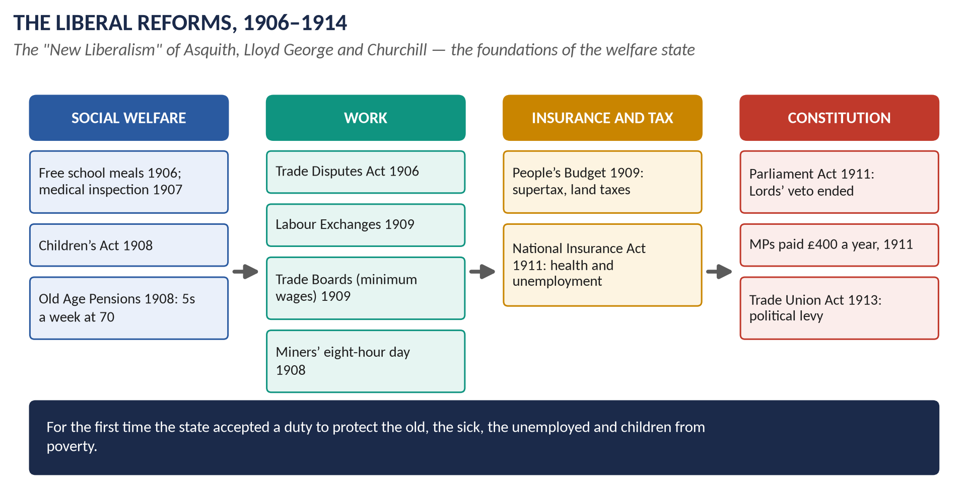
Figure 2 · The Liberal reforms, 1906–1914.

(i) Why the Liberals introduced reforms
1. The evidence of poverty (Booth, Rowntree) and of poor health (the Boer War recruits).
2. "New Liberalism": thinkers such as T. H. Green, L. T. Hobhouse and J. A. Hobson argued that true freedom required the state to remove poverty.
3. National efficiency: a healthy, educated workforce and army were needed to compete with Germany.
4. The Labour threat: the Liberals had to win working-class votes or lose them to Labour.
5. Personalities: Lloyd George and Churchill — dynamic, ambitious reformers; Lloyd George was inspired by Germany's social insurance (visit 1908).

(ii) Children
- Education (Provision of Meals) Act (1906): councils could provide free school meals.
- School medical inspections (1907); clinics from 1912.
- The Children's Act (1908) — "the Children's Charter": juvenile courts, borstals, protection from cruelty; no selling of tobacco or alcohol to children.

(iii) The old
- Old Age Pensions Act (1908): 5 shillings a week from the age of 70 for people with incomes under £21 a year (less for incomes up to £31 10s); paid at the post office, not the workhouse. About half a million people collected it on the first day (1 January 1909). Many wept: "God bless that Lord George."

(iv) Workers
- Trade Disputes Act (1906): reversed Taff Vale — unions could not be sued for strike losses.
- Workmen's Compensation Act (1906) extended.
- Miners' Eight Hours Act (1908).
- Labour Exchanges (1909): Churchill and William Beveridge — offices to help the unemployed find work.
- Trade Boards Act (1909): minimum wages in "sweated" trades (tailoring, chain-making, box-making, lace).
- Shops Act (1911): a half-day holiday.

(v) The People's Budget (1909)
To pay for pensions and the new Dreadnought battleships, Lloyd George proposed:
- higher income tax for the better-off; a supertax on incomes over £5,000;
- higher death duties;
- new land taxes on the increase in land values;
- taxes on tobacco, spirits, petrol and motor cars.
Lloyd George called it "a war budget … to wage implacable warfare against poverty and squalor". The House of Lords rejected it in November 1909 (by 350 to 75) — breaking the convention that the Lords did not reject money bills.

(vi) The constitutional crisis and the Parliament Act (1909–1911)
- January 1910 election: the Liberals lost their majority (274 seats to the Unionists' 272), relying on Labour and Irish MPs. The Lords passed the budget.
- The Liberals now set out to limit the Lords' veto. Edward VII died (May 1910); a conference failed; George V secretly promised to create enough Liberal peers if the Liberals won another election.
- December 1910 election: much the same result.
- The Parliament Act (August 1911) passed when the Lords gave way (131 to 114) under the threat of new peers:
  - the Lords could not delay money bills;
  - other bills could be delayed only for two years;
  - elections at least every five years (instead of seven).
- MPs were paid £400 a year from 1911.

(vii) National Insurance Act (1911)
- Part I — health: all workers earning under £160 a year paid 4d a week, the employer 3d and the state 2d — "ninepence for fourpence". In return: free medical care from a panel doctor, and sick pay of 10 shillings a week for 13 weeks.
- Part II — unemployment: for about 2¼ million workers in trades with seasonal unemployment (building, shipbuilding, engineering): 7 shillings a week for up to 15 weeks.
- Only the worker was covered — not wives or children.

(viii) Assessing the reforms
- For: the first great steps towards a welfare state; the state accepted responsibility for the old, the sick, the unemployed and children; they were the model for Beveridge (1942) and 1945–51.
- Against: limited — pensions low and late (few workers reached 70); insurance only for some workers; no family health cover; Labour saw them as too little; some workers resented compulsory contributions.

1.7 The great crises (1910–1914)
George Dangerfield's book The Strange Death of Liberal England (1935) argued that four "rebellions" were destroying Liberal England before the war:
1. The Lords (1909–11) — resolved by the Parliament Act.
2. The women: the suffragettes (WSPU) turned to window-smashing, arson and hunger strikes; the "Cat and Mouse Act" (1913) released hunger-strikers and re-arrested them when well; Emily Wilding Davison died at the Derby (June 1913). The suffragists (Millicent Fawcett's NUWSS) continued peacefully.
3. The workers: the "Great Unrest" (1910–14): the Tonypandy riots in South Wales (1910, Churchill sent troops); national dock and railway strikes (1911, two strikers shot at Llanelli); a national coal strike (1912) that won a minimum wage law; the Dublin lock-out (1913); the "Triple Alliance" of miners, railwaymen and transport workers (1914). Some workers were influenced by syndicalism — the idea that unions should take over industries through strikes.
4. Ireland: the Third Home Rule Bill (1912) led Ulster Unionists under Sir Edward Carson to sign the Ulster Covenant (1912) and arm the Ulster Volunteer Force; army officers threatened to resign rather than coerce Ulster (the Curragh incident, March 1914). Civil war seemed possible when the Great War intervened.

1.8 Edwardian foreign policy (1901–1914)
- The end of isolation (Topic 6): the Anglo-Japanese Alliance (1902), the Entente Cordiale (1904), the Anglo-Russian Convention (1907) → the Triple Entente.
- The naval race: Germany's Navy Laws (1898, 1900, 1906, 1908, 1912); Britain launched HMS Dreadnought (1906), a new type of all-big-gun battleship that made older ships obsolete — and gave Germany a chance to catch up. In 1909 the public demanded more: "We want eight and we won't wait."
- The Moroccan crises: 1905–06 (Tangier, Algeciras) and 1911 (Agadir — the German gunboat Panther; Lloyd George's Mansion House speech warned Germany).
- Military talks with France (from 1906): plans for a British Expeditionary Force (BEF) to fight beside the French.
- The Anglo-French naval agreement (1912): the French fleet concentrated in the Mediterranean, the British in the North Sea and Channel — a moral obligation to defend France's northern coast.
- Haldane's army reforms (1906–12): the BEF of six divisions; the Territorial Force (1908); the Imperial General Staff.
- Grey's diplomacy: the London Conference during the Balkan Wars (1912–13); attempts at naval agreement with Germany (the Haldane mission, 1912) failed.

Chapter 2 · The Rise of the Labour Movement and the Labour Party

2.1 What was the Labour movement?
Three strands that joined together:
1. The trade unions — the largest and richest part.
2. The socialist societies — groups of thinkers and activists.
3. The Labour Party — the political arm, to win seats in Parliament.

2.2 The roots (before 1900)

(i) Trade unions
- "New Model" unions of skilled workers (the Amalgamated Society of Engineers, 1851); the TUC (1868); legal status (1871, 1875).
- "New Unionism" (1888–89): unskilled workers organised — the match girls' strike at Bryant and May (1888), the gas workers (1889) and the great London Dock Strike (1889), which won "the docker's tanner" (6d an hour). Union membership rose from about 750,000 (1888) to about 2 million (1900).

(ii) Socialist societies
- The Social Democratic Federation (1881, H. M. Hyndman) — Marxist.
- The Fabian Society (1884) — gradual, parliamentary socialism (Topic 4).
- The Independent Labour Party (ILP), founded at Bradford in January 1893 by Keir Hardie.

(iii) Working men in Parliament
- The "Lib-Labs": from 1874 a few miners' leaders sat as Liberals.
- Keir Hardie, a Scottish miner, was elected for West Ham South in 1892 as an independent labour MP — he arrived in a cloth cap.
- Why a separate party? The Liberal Party would not choose working men as candidates in most seats, and it would not support socialist aims.

2.3 The Labour Representation Committee (1900)
- Founded on 27 February 1900 at the Memorial Hall, Farringdon Street, London, by delegates of trade unions, the ILP, the SDF and the Fabians.
- Aim: "a distinct Labour group in Parliament" — working-class MPs, whatever their ideas.
- Secretary: James Ramsay MacDonald.
- 1900 election: only 2 MPs (Keir Hardie and Richard Bell).

2.4 The Edwardian breakthrough (1901–1914)
Year | Event
1901 | Taff Vale: unions could be sued for strike losses → many unions affiliated to the LRC; membership rose from about 350,000 to almost 1 million.
1903 | The secret Gladstone–MacDonald pact: the Liberals would not oppose LRC candidates in about 30 seats.
1906 | 29 LRC MPs elected; renamed the Labour Party; Keir Hardie chairman.
1906 | The Trade Disputes Act reversed Taff Vale — Labour's first great success.
1908–09 | The Miners' Federation joined Labour (its MPs came over from the Liberals).
1909 | The Osborne judgment: the Lords ruled that unions could not use their funds for political purposes — a threat to Labour's money.
1910 | 40 MPs (January), 42 (December).
1911 | Payment of MPs (£400) — working men could now afford to sit.
1913 | Trade Union Act: unions could have a political fund if members voted for it; individuals could "contract out".
1910–14 | The Great Unrest; union membership reached about 4 million by 1914.

2.5 The significance of the Edwardian Labour movement
1. Independent working-class representation: for the first time working men sat in Parliament as a separate party, not as junior Liberals.
2. It pushed the Liberals to reform: the Trade Disputes Act (1906), school meals (a Labour private member's bill, 1906), pensions, National Insurance, payment of MPs — the Liberals needed Labour's votes and feared its competition.
3. Class became the basis of politics: the Edwardian years began the shift from politics based on religion and region to politics based on class.
4. Union strength: the Great Unrest showed the new power of organised labour.
5. Foundations for the future: organisation, funds (the political levy), and experience — ready for the opportunities of the war.
6. But limits: before 1914 Labour was still small (about 40 MPs), depended on the Liberal pact, won few three-cornered contests, and had no distinct programme; many historians (e.g. P. F. Clarke) think the Liberals were still healthy in 1914.

2.6 The war and the new party (1914–1918)
- Split over the war: most Labour MPs and unions supported it; MacDonald opposed it and resigned the leadership; Arthur Henderson became leader.
- In government: Henderson joined Asquith's coalition (1915) and Lloyd George's war cabinet (1916–17) — Labour gained experience of office.
- Unions stronger: membership doubled to about 8.3 million by 1920.
- The 1918 constitution (Henderson and Sidney Webb): individual membership and local parties across the country; Clause IV — common ownership of "the means of production, distribution and exchange"; the programme Labour and the New Social Order.
- The 1918 Representation of the People Act gave the vote to all men over 21 — most new voters were working-class.

2.7 Labour between the wars (1918–1939)
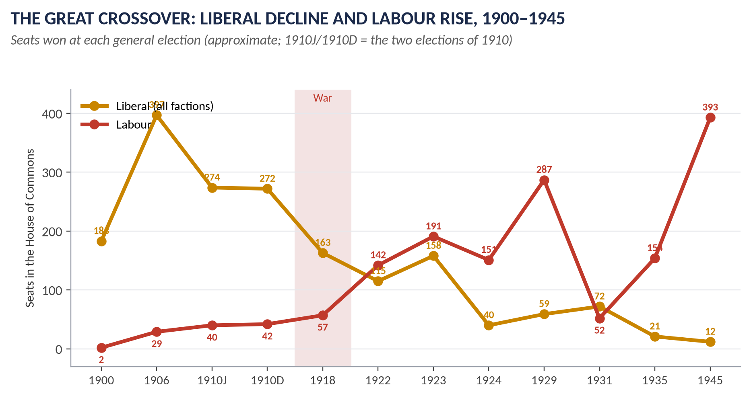
Figure 3 · The great crossover: Liberal decline and Labour rise.
Year | Event
1918 | 57 seats (the "coupon" election).
1922 | 142 seats — Labour becomes the official opposition, overtaking the divided Liberals.
1923 | 191 seats.
1924 | First Labour government (January–November) under MacDonald, a minority depending on Liberal votes. Wheatley's Housing Act (council houses for rent); recognition of the Soviet Union. It fell over the Campbell case; the Zinoviev letter (a forged "Communist" letter printed by the Daily Mail) helped the Conservatives win the election.
1926 | The General Strike (Chapter 9).
1929 | 287 seats — the largest party for the first time. Second Labour government (1929–31): Coal Mines Act, Housing Act (1930, slum clearance).
1931 | The financial crisis: the May Committee demanded cuts; the cabinet split over a 10 per cent cut in unemployment benefit; MacDonald formed a National Government with the Conservatives and Liberals and was expelled from Labour. At the election Labour won only 52 seats.
1935 | Clement Attlee became leader; 154 seats.

2.8 Labour in power — the achievements (1940–2026)

(i) The wartime coalition (1940–45)
Attlee (Deputy PM), Ernest Bevin (Minister of Labour), Herbert Morrison — Labour ministers ran the home front. The Beveridge Report (1942) set out the welfare state.

(ii) The Attlee government (1945–51) — the great achievements
The 1945 election: 393 seats, a majority of 146.
1. The National Health Service (5 July 1948, Aneurin Bevan): free medical care for all at the point of use.
2. National Insurance Act (1946): pensions, sickness, unemployment and maternity benefits for everyone "from the cradle to the grave".
3. National Assistance Act (1948): the end of the Poor Law.
4. Family allowances (1945–46).
5. Nationalisation of about 20 per cent of the economy: the Bank of England (1946), coal (1947), railways and electricity (1948), gas (1949), iron and steel (1951).
6. Housing: over a million homes built; New Towns Act (1946).
7. Education: the 1944 Butler Act put into effect; school-leaving age raised to 15 (1947).
8. Independence for India and Pakistan (1947), Burma and Ceylon (1948).
9. Foreign policy: founding member of NATO (1949); the Marshall Plan; Britain's atomic bomb programme.
10. Full employment maintained.

(iii) Later Labour governments
- Harold Wilson (1964–70, 1974–76): the Open University (1969); abolition of the death penalty (1965); legal reforms on homosexuality, abortion and divorce; Race Relations Acts (1965, 1968); Equal Pay Act (1970); comprehensive schools; the 1975 EEC referendum.
- James Callaghan (1976–79).
- Tony Blair (1997–2007): the national minimum wage (1999); Bank of England independence (1997); devolution to Scotland and Wales (1999); the Good Friday Agreement (1998); the Human Rights Act (1998); Sure Start; civil partnerships (2004); the Iraq War (2003) was his most controversial act.
- Gordon Brown (2007–10): the response to the 2008 financial crisis; the Climate Change Act (2008).
- Keir Starmer: won the 4 July 2024 election with 411 seats — Labour's second-largest landslide.
WHAT THE EXAMINER HAS ASKED · Where Chapters 1–2 have been asked
2021 Q5 (what is the Edwardian era? the rise and significance of the Labour movement) · 2022 Q4 (the rise of the Labour Party and its achievements). MCQ 2025: the Edwardian era is named after Edward VII.

Chapter 3 · The Causes of the First World War
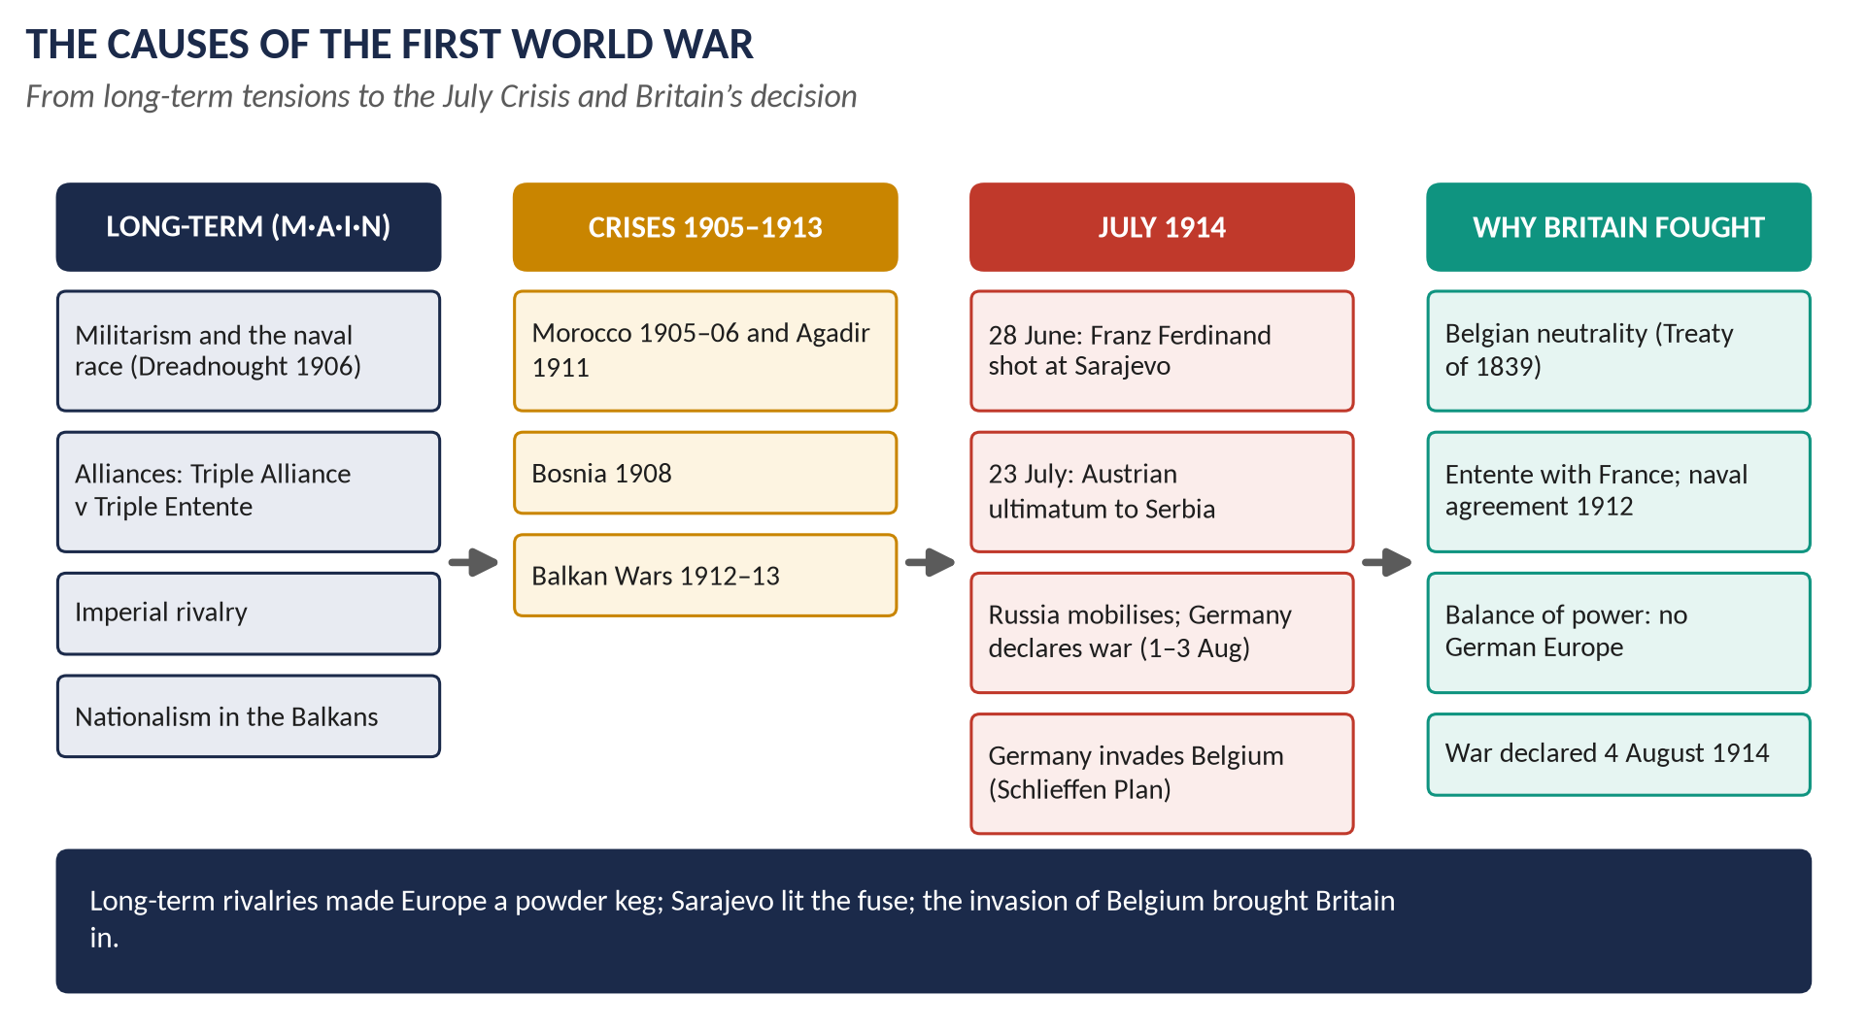
Figure 4 · The causes of the First World War.

3.1 The long-term causes — "M·A·I·N"

(i) Militarism
- The great powers built huge conscript armies and detailed war plans — Germany's Schlieffen Plan (attack France through Belgium, then turn on Russia), France's Plan XVII.
- The Anglo-German naval race: Germany's Navy Laws (from 1898) aimed at a fleet that could challenge Britain; Britain's Dreadnought (1906) and "We want eight" (1909). By 1914 Britain had 29 dreadnoughts, Germany 17. The race poisoned Anglo-German relations.

(ii) Alliances
- The Triple Alliance (1882): Germany, Austria-Hungary, Italy.
- The Triple Entente: the Franco-Russian Alliance (1894), the Entente Cordiale (1904), the Anglo-Russian Convention (1907).
- Alliances meant a local quarrel could quickly become a general war.

(iii) Imperialism
Competition for colonies and influence — Africa, the Near East, China — created suspicion, especially between Germany (which wanted "a place in the sun") and Britain and France.

(iv) Nationalism
- Pan-Slavism: Russia as protector of the Slavs; Serbia wanted to unite the South Slavs, including those inside Austria-Hungary (Bosnia).
- French revanche: France wanted Alsace-Lorraine back (lost in 1871).
- Popular nationalism in all countries, whipped up by newspapers.

3.2 The crises (1905–1913)
- The First Moroccan Crisis (1905–06): the Kaiser at Tangier; Algeciras — Britain backed France; the Entente strengthened.
- The Bosnian Crisis (1908): Austria annexed Bosnia; Russia, not ready for war, was humiliated and determined not to give way again.
- The Agadir Crisis (1911): the German gunboat Panther; Lloyd George's warning; Britain and France drew closer.
- The Balkan Wars (1912–13): Serbia doubled in size; Austria saw Serbia as a deadly threat.

3.3 The July Crisis (1914)
Date | Event
28 June | Archduke Franz Ferdinand, heir to Austria-Hungary, and his wife were shot in Sarajevo (Bosnia) by Gavrilo Princip, a Bosnian Serb linked to the Serbian Black Hand society.
5–6 July | Germany gave Austria the "blank cheque" — full support for action against Serbia.
23 July | Austria's ultimatum to Serbia — ten harsh demands, to be accepted in 48 hours.
25 July | Serbia accepted most demands; Austria broke off relations.
28 July | Austria declared war on Serbia.
30 July | Russia ordered general mobilisation.
1 August | Germany declared war on Russia.
3 August | Germany declared war on France and demanded passage through Belgium; Belgium refused.
4 August | Germany invaded Belgium. Britain's ultimatum expired at 11 p.m.; Britain declared war on Germany.

3.4 Why Britain went to war
1. Belgium: the Treaty of London (1839) guaranteed Belgian neutrality. Germany's chancellor Bethmann Hollweg asked whether Britain would go to war for "a scrap of paper". The invasion united the cabinet, Parliament and the public.
2. France and the Entente: the military conversations (from 1906) and the 1912 naval agreement created a moral obligation to defend France's Channel coast.
3. The balance of power: a German victory over France and Russia would make Germany master of Europe and the Channel ports — a mortal danger to Britain.
4. The German navy: the naval race had made Germany seem Britain's main enemy.
5. Politics: the Liberal cabinet would have split without a clear cause; Belgium provided it.
Grey, on 3 August 1914: "The lamps are going out all over Europe; we shall not see them lit again in our lifetime."

3.5 Who was to blame? — the historians
Historian | View
Versailles, Article 231 (1919) | Germany and its allies were responsible.
Fritz Fischer, Germany's Aims in the First World War (1961) | Germany deliberately sought a war to become a world power.
A. J. P. Taylor | War "by timetable": mobilisation plans ran out of control.
Niall Ferguson, The Pity of War (1998) | Britain's entry was a mistake; it turned a continental war into a world war.
Christopher Clark, The Sleepwalkers (2012) | All the powers shared responsibility; leaders "sleepwalked" into war.
Margaret MacMillan, The War that Ended Peace (2013) | Choices by a few leaders, not inevitable forces.

Chapter 4 · Britain in the First World War, 1914–1918

4.1 The course of the war — in brief
Year | Events
1914 | The BEF fought at Mons (August), the Marne (September; the German advance on Paris stopped) and First Ypres (October–November). The "race to the sea"; trenches from the Channel to Switzerland. Unofficial Christmas truce.
1915 | Second Ypres (first poison gas); Gallipoli (April 1915 – January 1916) — Churchill's plan to knock out Turkey failed; about 44,000 Allied dead. The "shell crisis" (May). Loos (September).
1916 | Jutland (31 May): the only great naval battle; British losses heavier, but the German fleet never came out again. The Somme (1 July – November 1916): 57,470 British casualties on the first day, including about 19,240 dead; about 420,000 British casualties in all. The first tanks (September).
1917 | Germany's unrestricted submarine warfare (February) nearly starved Britain; convoys saved it. The USA entered the war (April). Passchendaele (Third Ypres, July–November) in mud. Revolution in Russia; Russia left the war. The Balfour Declaration (November).
1918 | The German Spring Offensive (March) broke through, then stalled. The Allied "Hundred Days" offensive (from 8 August, Amiens). Germany's allies collapsed; the Kaiser abdicated. Armistice: 11 a.m., 11 November 1918.

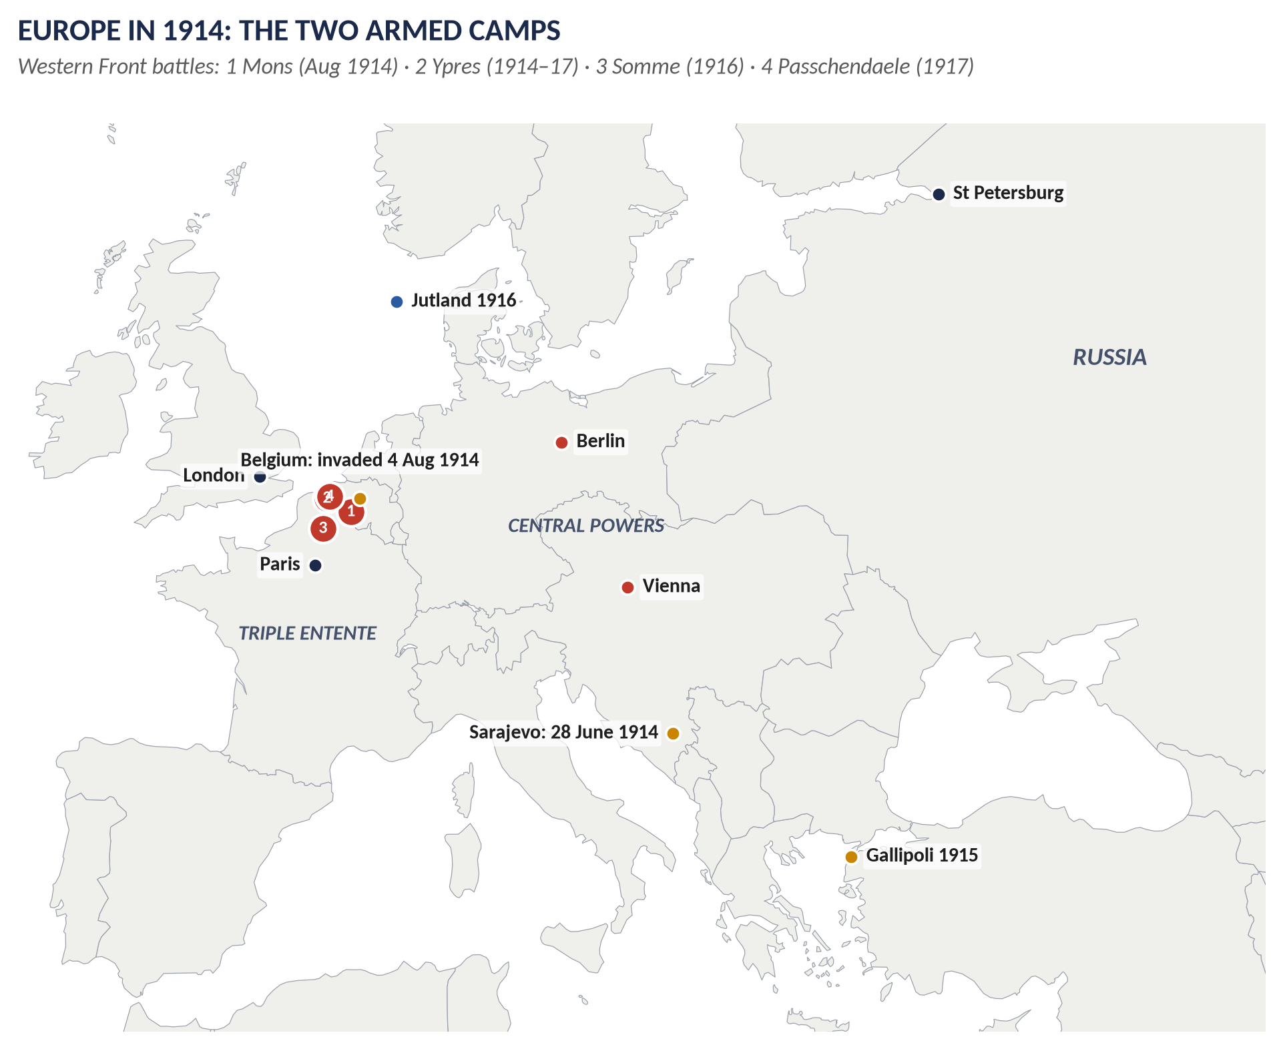
Figure 5 · Europe in 1914 and the Western Front.

4.2 Government and politics in the war
- Asquith's Liberal government (1914–15): "business as usual" at first.
- The Defence of the Realm Act (DORA, 8 August 1914): wide powers — censorship, control of industry and land, restrictions on pubs (licensing hours; weaker beer), British Summer Time (1916).
- The shell crisis (May 1915) and the resignation of Admiral Fisher → coalition government (Liberals, Conservatives and Labour); Lloyd George became Minister of Munitions.
- Conscription: the Military Service Act (January 1916) for single men aged 18–41, extended to married men (May 1916) — a breach of Liberal principle; about 16,000 conscientious objectors.
- December 1916: Lloyd George, backed by the Conservatives, replaced Asquith as PM; a small War Cabinet. The Liberal Party split into Asquith and Lloyd George factions.
- Two Prime Ministers led Britain during the war: Asquith (1914–16) and Lloyd George (1916–18).
- The Maurice debate (May 1918): 98 Liberals voted with Asquith against Lloyd George — deepening the split.

4.3 The home front
- Volunteers: about 2.5 million men volunteered by early 1916.
- Women's work: about 1.5 million more women entered paid work; about 950,000 in munitions ("munitionettes", with yellow skin from TNT); women in transport, offices, farms (the Women's Land Army, 1917) and the auxiliary services (WAAC, WRNS, WRAF).
- Food: German U-boats sank supply ships; rationing of sugar, meat, butter (1918).
- Air raids: Zeppelins (from 1915) and Gotha bombers (1917) — about 1,400 civilians killed.
- Propaganda: posters, films, atrocity stories (the Bryce Report, 1915); the royal family changed its German name to Windsor (1917).
- State control: of railways, mines, shipping, food; the state spent over half the national income.

4.4 Lord Kitchener (1850–1916)

(i) The imperial soldier
- Born in County Kerry, Ireland, 1850; Royal Engineers.
- Sirdar (commander) of the Egyptian army (1892); reconquered the Sudan — victory at Omdurman (2 September 1898); "Kitchener of Khartoum".
- Faced the French at Fashoda (1898) and handled the crisis firmly but tactfully.
- Boer War: chief of staff to Lord Roberts, then commander (1900–02); ended Boer guerrilla resistance with blockhouses, farm-burning and concentration camps; negotiated Vereeniging (1902).
- Commander-in-Chief in India (1902–09): his quarrel over control of the army led to the resignation of the Viceroy Lord Curzon (1905).
- Consul-General in Egypt (1911–14).

(ii) The war minister (1914–16)
- Secretary of State for War from 5 August 1914 — the first serving soldier in the cabinet since 1660.
- Almost alone he predicted a long war of at least three years and a need for millions of men.
- The famous poster "Your Country Needs You" (Alfred Leete, 1914); the "New Armies" ("Kitchener's Army") of volunteers, including the Pals battalions.
- Criticism: a poor administrator who would not delegate; blamed for the shell shortage (1915); lost control of munitions to Lloyd George and of strategy to the General Staff (Sir William Robertson).
- Death: drowned when HMS Hampshire struck a German mine off Orkney on 5 June 1916, on the way to Russia.
- Verdict: a great imperial soldier and an inspiring symbol; his foresight about a long war and his creation of a mass army were vital to victory, but he was ill-suited to cabinet government and modern industrial war.

4.5 Was British policy in the war justified? — the issues
- Entry: defence of Belgium and of the balance of power — widely seen as just; but secret Entente commitments and Grey's failure to warn Germany clearly are criticised.
- Propaganda and hatred: the Bryce Report exaggerated German atrocities; anti-German riots (after the Lusitania sinking, May 1915); Kipling (who lost his son John at Loos, 1915): "there are only two divisions in the world today — human beings and Germans".
- Conduct: the naval blockade of Germany (hundreds of thousands of German civilians died of hunger-related causes); the massive losses of the Western Front.
- Secret diplomacy: the Treaty of London (1915) promised Italy Austrian lands; the Sykes–Picot Agreement (1916) divided Arab lands with France; the McMahon–Hussein correspondence (1915–16) promised Arab independence; the Balfour Declaration (1917) promised a Jewish "national home" in Palestine — contradictory promises with long consequences.
- The peace: "Hang the Kaiser" and "make Germany pay" in the 1918 election; but Lloyd George's Fontainebleau Memorandum (March 1919) argued for moderation.

Chapter 5 · The Effects of the First World War on Britain
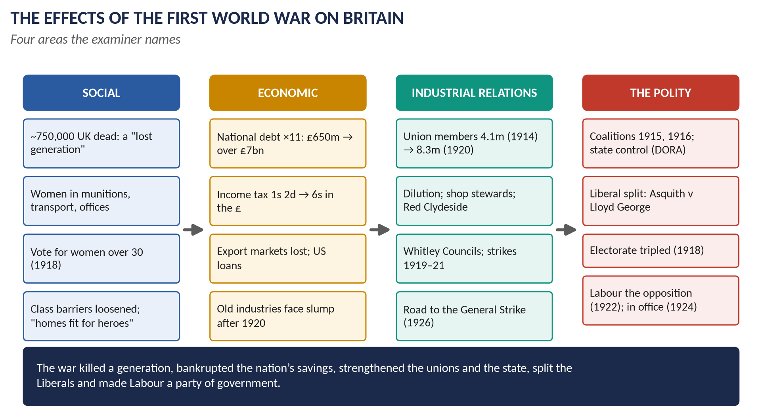
Figure 6 · The effects of the First World War on Britain.

5.1 Human cost
- About 750,000 servicemen from the UK died (close to a million from the whole Empire); about 1.6 million wounded; many with shell shock.
- The dead were mostly young men — "the lost generation" — including a high proportion of junior officers from the upper and middle classes.
- The Spanish flu (1918–19) killed about 228,000 more in Britain.
- Remembrance: the Cenotaph (1919–20), the Unknown Warrior (1920), the poppy (1921), war memorials in every village.

5.2 Economic effects
1. Debt: the national debt rose about eleven-fold, from about £650 million (1914) to over £7 billion (1919); interest payments took a large share of the budget in the 1920s.
2. Taxation: the standard rate of income tax rose from 1s 2d to 6s in the pound; many more people paid it.
3. Overseas assets: about a quarter of British foreign investments were sold; Britain borrowed heavily from the USA — New York began to replace London as the world's financial centre.
4. Lost markets: while Britain made war goods, others (the USA, Japan) took its export markets — especially in cotton and coal.
5. Inflation: prices roughly doubled (1914–18).
6. Old industries: coal, cotton, shipbuilding and steel boomed during the war but slumped after 1920; unemployment never fell below 1 million between the wars.
7. New industries and methods: chemicals, motor vehicles, aircraft, electrical goods; mass production; state control showed what planning could do.
8. Shipping: about 7.7 million tons of British merchant shipping sunk.

5.3 Social effects
1. Women: new jobs, independence and confidence; the vote for women over 30 (1918); the Sex Disqualification (Removal) Act (1919) opened professions. But most women returned to domestic roles after 1918.
2. Class: the upper classes lost many sons and much wealth (death duties; land sales — about a quarter of England changed hands in 1918–21); the officer corps opened to the middle classes; soldiers of all classes shared the trenches.
3. Living standards: for many workers wages rose and unemployment vanished; nutrition of the poor improved with rationing.
4. The state: people got used to government control; "homes fit for heroes" — the Addison Housing Act (1919) — the first large council-house programme.
5. Education and welfare: the Fisher Education Act (1918) raised the school-leaving age to 14; the Ministry of Health (1919); unemployment insurance extended (1920).
6. Culture and attitudes: disillusion in the war poets (Wilfred Owen, Siegfried Sassoon); declining deference; the "Roaring Twenties".

5.4 Effects on industrial relations
1. Union strength: membership doubled from 4.1 million (1914) to 8.3 million (1920).
2. Partnership with the state: the Treasury Agreement (1915): unions accepted dilution (unskilled workers doing skilled jobs) and no strikes in return for consultation and profit limits.
3. Shop stewards: local workplace leaders became powerful; Red Clydeside (Glasgow, 1915–19): rent strikes (1915), the "40-hours strike" (1919), tanks in George Square.
4. Whitley Councils (1917): joint councils of employers and workers.
5. Post-war conflict: a huge strike wave in 1919 (police, railways); the Sankey Commission on the mines (1919) recommended nationalisation, which Lloyd George rejected; Black Friday (April 1921) — the Triple Alliance collapsed; the road led to the General Strike (1926).

5.5 Effects on the polity
1. Coalition government (1915–22) and a much bigger, more active state.
2. The Representation of the People Act (1918): all men over 21, women over 30 — the electorate rose from about 7.7 million to about 21.4 million, most of them new working-class and women voters.
3. The Liberal split: Asquith v Lloyd George (1916); the Maurice debate (1918); the "coupon election" (December 1918) — Lloyd George's coalition candidates received a letter of support (the "coupon"); Asquith's Liberals won only about 36 seats and he lost his own seat.
4. Labour's rise: in government in wartime; the new constitution (1918); the official opposition (1922); in office (1924).
5. Ireland: the Easter Rising (1916); Sinn Féin won 73 seats (1918); the Irish Free State (1922).
6. The Empire: the Dominions' contribution (Canada, Australia, New Zealand, South Africa, India — over 1.3 million Indians served) increased their demand for equality — leading to the Balfour Declaration of 1926 and the Statute of Westminster (1931) (Topic 8).

5.6 How the war accelerated the decline of the Liberal Party

(i) Before the war — was the Liberal Party already dying?
- Dangerfield (1935): yes — the Lords, the suffragettes, the strikes and Ulster were destroying Liberal England by 1914.
- P. F. Clarke and Trevor Wilson: no — New Liberalism was winning working-class support; Labour was a junior partner; Liberals won by-elections.
- Ross McKibbin: the growth of class feeling and the narrow pre-1918 franchise hid Labour's real potential.

(ii) How the war hurt the Liberals
1. Principles: war demanded conscription, censorship, DORA, state control of industry — contrary to Liberal ideas of freedom and free trade (the McKenna duties of 1915 even taxed imports).
2. Leadership split: Asquith v Lloyd George (December 1916) divided the party at every level; there were two Liberal parties until 1923.
3. The coupon election (1918): Lloyd George's Liberals were tied to the Conservatives; Asquith's were crushed.
4. Loss of identity: when the coalition collapsed (1922), the Liberals had no clear cause.
5. Trevor Wilson's image: the war was like "a rampant omnibus" that ran down the Liberal Party.

(iii) How the war paved the way for Labour
1. Office: Henderson in the war cabinet gave Labour respectability.
2. Unity: unlike the Liberals, Labour was not split in office.
3. Organisation: the 1918 constitution, local parties, a socialist programme.
4. The franchise of 1918 gave the vote to millions of working men.
5. The unions, doubled in size, funded Labour.
6. Results: official opposition (1922), government (1924), largest party (1929).

Chapter 6 · The Peace Settlement, 1919–1923
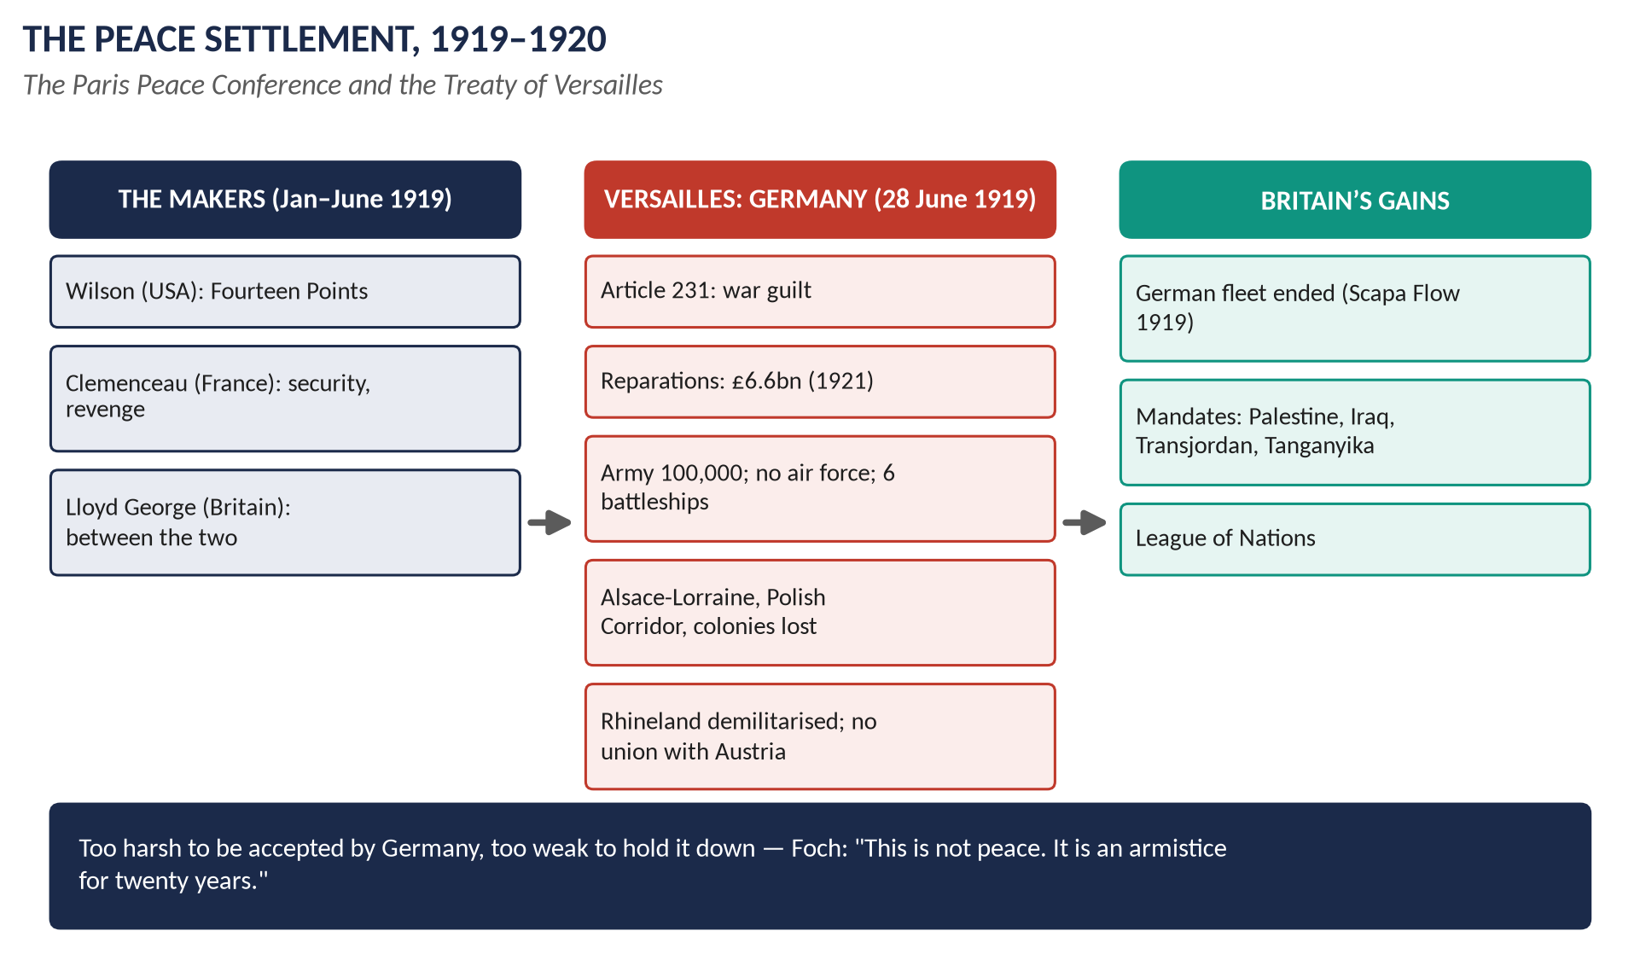
Figure 7 · The peace settlement.

6.1 The Paris Peace Conference (January–June 1919)
- The "Big Three": Woodrow Wilson (USA) — a just peace based on his Fourteen Points (January 1918), self-determination and a League of Nations; Georges Clemenceau (France) — security and revenge, a weak Germany; David Lloyd George (Britain) — between the two: punish Germany enough to satisfy British voters, but keep it strong enough to trade and to balance France and Bolshevik Russia.
- Lloyd George's Fontainebleau Memorandum (March 1919) warned that a harsh peace would drive Germany to revenge or Bolshevism.
- Germany was not invited to negotiate — a "Diktat" (dictated peace).

6.2 The Treaty of Versailles (28 June 1919)
Signed in the Hall of Mirrors at Versailles — five years to the day after Sarajevo.

(i) Territory
- Alsace-Lorraine to France; the Saar under the League for 15 years (France to have its coal); small areas to Belgium and Denmark.
- West Prussia and Posen to Poland — the "Polish Corridor" to the sea, cutting off East Prussia; Danzig a Free City under the League.
- Memel to the Allies (later Lithuania).
- All colonies lost — given as mandates to Britain, France, Japan, South Africa, Australia, New Zealand.
- Union (Anschluss) with Austria forbidden.

(ii) Military
- Army limited to 100,000 men; no conscription; no tanks; no air force; navy limited to 6 battleships, no submarines.
- The Rhineland demilitarised and occupied by the Allies for 15 years.

(iii) Guilt and reparations
- Article 231, the "War Guilt Clause": Germany and its allies accepted responsibility for causing the war's losses.
- Reparations: fixed in 1921 at 132 billion gold marks (about £6,600 million).

(iv) The League
The Covenant of the League of Nations formed the first part of the treaty.

6.3 The other treaties
Treaty | Country and main terms
St Germain (Sept 1919) | Austria: lost huge lands; independence of Czechoslovakia, Yugoslavia, Poland recognised; Anschluss forbidden.
Neuilly (Nov 1919) | Bulgaria: lost lands to Greece, Yugoslavia, Romania.
Trianon (June 1920) | Hungary: lost two-thirds of its territory.
Sèvres (Aug 1920) | Turkey: Arab lands to British and French mandates; replaced after Turkish victories by Lausanne (1923).

6.4 Britain and the settlement
- Britain's gains: the German fleet (scuttled at Scapa Flow, June 1919) and German naval rivalry ended; German colonies as mandates (Tanganyika, parts of Togo and Cameroon); from Turkey, Palestine, Transjordan and Iraq as mandates. The empire reached its largest extent.
- Britain's doubts: many British people soon thought the treaty too harsh — J. M. Keynes, The Economic Consequences of the Peace (1919), called it a "Carthaginian peace". This guilt shaped appeasement in the 1930s.
- Foch: "This is not peace. It is an armistice for twenty years."

6.5 Judging the settlement
- Too harsh: Germany humiliated (war guilt, Diktat), reparations resented, Germans left outside Germany (Sudetenland, Danzig) — fuel for Hitler.
- Too weak: Germany remained united and potentially the strongest power in Europe; the USA and Britain would not guarantee France's security; there was no way to enforce it.
- Understandable: the peacemakers faced revolution, starvation, new nations and furious public opinion; historians such as Margaret MacMillan (Peacemakers, 2001) argue it was not the main cause of the Second World War — the failure to enforce it was.

Chapter 7 · The League of Nations, 1920–1946
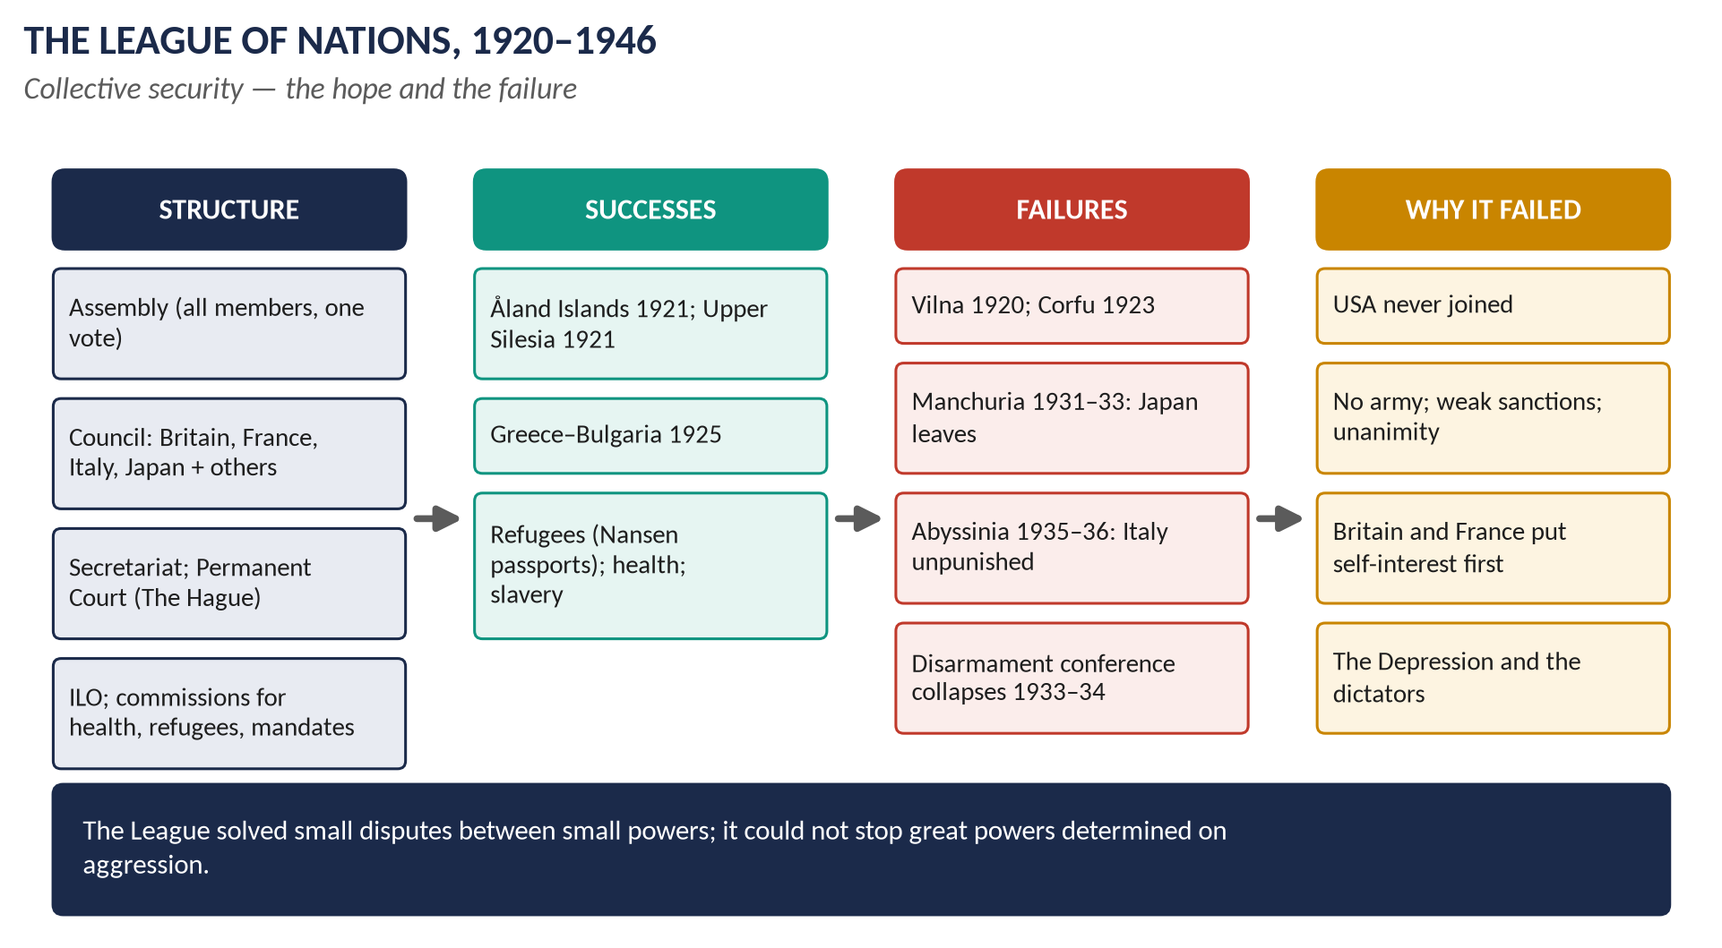
Figure 8 · The League of Nations.

7.1 Origins and aims
- Wilson's Fourteenth Point: "a general association of nations" to guarantee independence and territory for great and small states alike.
- British supporters: Lord Robert Cecil, Jan Smuts (South Africa), the League of Nations Union (over 400,000 members by the 1930s).
- The Covenant (26 articles) was part of the peace treaties; the League came into being on 10 January 1920, with its headquarters at Geneva, Switzerland.
- Aims:
1. Collective security — prevent war by joint action against any aggressor. 2. Settle disputes by arbitration and discussion. 3. Disarmament. 4. Improve living and working conditions worldwide. 5. Supervise the mandates.

7.2 Structure
Organ | Role
The Assembly | All members, one vote each; met once a year; decisions usually unanimous.
The Council | Permanent members: Britain, France, Italy, Japan (Germany 1926–33, USSR 1934–39); plus elected members; met several times a year; handled crises.
The Secretariat | The civil service (Secretary-General Sir Eric Drummond, 1920–33).
The Permanent Court of International Justice | At The Hague; legal disputes between states.
The International Labour Organisation (ILO) | Working conditions; still exists today.
Commissions | Mandates, refugees, health, slavery, drugs, disarmament.

Sanctions (Article 16): moral condemnation → economic sanctions → in theory, military action by members (the League had no army of its own).
Membership: 42 at the start; a peak of 58 (1934–35). The USA never joined — the Senate refused to ratify Versailles (1919–20). Germany joined in 1926, the USSR in 1934.

7.3 The work of the League

(i) Political successes
- The Åland Islands (1921): awarded to Finland, with safeguards for the Swedish inhabitants — both accepted.
- Upper Silesia (1921): a plebiscite and partition between Germany and Poland.
- Albania (1921): Yugoslav troops withdrew.
- Greece and Bulgaria (1925): the League stopped a Greek invasion (the Petrich incident); Greece paid compensation.
- Mosul (1926): awarded to British-mandated Iraq rather than Turkey.
- The Saar (1920–35): governed by the League; a fair plebiscite returned it to Germany (1935).

(ii) Humanitarian successes
- Refugees and prisoners: Fridtjof Nansen returned about 400,000 prisoners of war and created the "Nansen passport" for stateless refugees.
- Health: the Health Organisation fought leprosy, malaria and typhus; forerunner of the WHO.
- Slavery: about 200,000 slaves freed in Sierra Leone; campaigns in Africa and Asia.
- Drugs: controls on the opium and drug trade.
- The ILO: the 48-hour week, limits on child labour.
- Financial help: rescued the economies of Austria and Hungary (1922–23).

(iii) Failures
- Vilna (1920): Poland seized it from Lithuania; the League did nothing.
- Corfu (1923): Mussolini bombarded and occupied Corfu; the League made Greece pay compensation.
- The Ruhr (1923): France and Belgium occupied it; the League did nothing.
- Manchuria (1931–33): Japan invaded; the Lytton Report (1932) condemned Japan, which simply left the League (1933).
- Disarmament: the World Disarmament Conference (1932–34) failed; Germany left the conference and the League (October 1933).
- Abyssinia (1935–36): Italy invaded Ethiopia. The League imposed sanctions but not on oil, and Britain kept the Suez Canal open; the Hoare–Laval Pact (December 1935) secretly offered Italy much of Abyssinia — a public scandal. Italy conquered Abyssinia (May 1936) and left the League (1937). This was the League's death blow.
- 1936–39: the League was ignored over the Rhineland, Spain, Austria, Czechoslovakia and Poland. The USSR was expelled (1939) for attacking Finland.
- The League was formally dissolved in April 1946; its work passed to the United Nations (1945).

7.4 Why the League failed
1. The USA never joined — the world's greatest economic power was absent, so sanctions could be evaded.
2. No army: it depended on members, who would not fight for distant causes.
3. Weak sanctions: economic sanctions were slow, partial and easily broken.
4. Unanimity: decisions needed all members to agree.
5. Britain and France: the League's leading members put national interests first, were weakened by the war and the Depression, and would not risk war (Abyssinia, Hoare–Laval).
6. Membership: Germany (until 1926) and the USSR (until 1934) excluded; Japan, Germany and Italy left.
7. Linked to Versailles: the defeated saw it as a club of the victors.
8. The Great Depression made countries selfish and aggressive and destroyed support for sanctions.
9. The dictators: Hitler, Mussolini and the Japanese militarists were determined on aggression and did not care about world opinion.

Chapter 8 · British Foreign Policy, 1919–1939

8.1 Britain's aims and position
- Aims: peace; security of the empire and trade routes; revival of trade; economy in defence spending.
- Weaknesses: debts; economic decline; an over-stretched empire (Ireland, India, Egypt, Palestine); Dominions unwilling to fight Europe's wars; a public determined never to repeat 1914–18.
- The Ten Year Rule (August 1919): the armed services should assume no major war for ten years — renewed each year until 1932.

8.2 Phase 1 · 1919–1923: making and defending the settlement
- Versailles and the League (Chapters 6–7).
- The Washington Naval Conference (1921–22): battleship tonnage in the ratio 5 : 5 : 3 (Britain : USA : Japan) — Britain accepted parity with the USA; the Anglo-Japanese Alliance was ended (replaced by the Four-Power Treaty).
- Russia: intervention against the Bolsheviks (1918–19) ended; the Anglo-Soviet Trade Agreement (1921).
- The Chanak crisis (September 1922): Lloyd George threatened war with Turkey; the Dominions refused support; Conservative MPs at the Carlton Club voted to leave the coalition (October 1922) — Lloyd George fell.

8.3 Phase 2 · 1924–1929: conciliation — "the spirit of Locarno"
- MacDonald (1924): recognised the USSR; supported the Dawes Plan (1924), which reduced reparation payments and brought American loans to Germany; backed the Geneva Protocol (arbitration) — rejected by the Conservatives (1925).
- The Locarno Treaties (October–December 1925), Austen Chamberlain (Foreign Secretary, Nobel Peace Prize): Germany, France and Belgium accepted their western borders; Britain and Italy guaranteed them. Germany joined the League (1926).
- The Kellogg–Briand Pact (1928): over 60 nations renounced war as an instrument of policy.
- The Young Plan (1929) further reduced reparations; the Allies left the Rhineland (1930).

8.4 Phase 3 · 1929–1935: depression and disarmament
- The London Naval Treaty (1930).
- Manchuria (1931): Britain would not act against Japan.
- The Disarmament Conference (1932–34) failed; Hitler left it (1933).
- Hitler's rearmament: conscription announced (March 1935).
- The Stresa Front (April 1935): Britain, France and Italy protested — but it collapsed within weeks.
- The Anglo-German Naval Agreement (June 1935): Britain allowed Germany a navy 35 per cent of Britain's surface fleet — breaking Versailles without consulting France.
- The Peace Ballot (1935): over 11 million people voted for the League and for economic sanctions.

8.5 Phase 4 · 1935–1938: appeasement
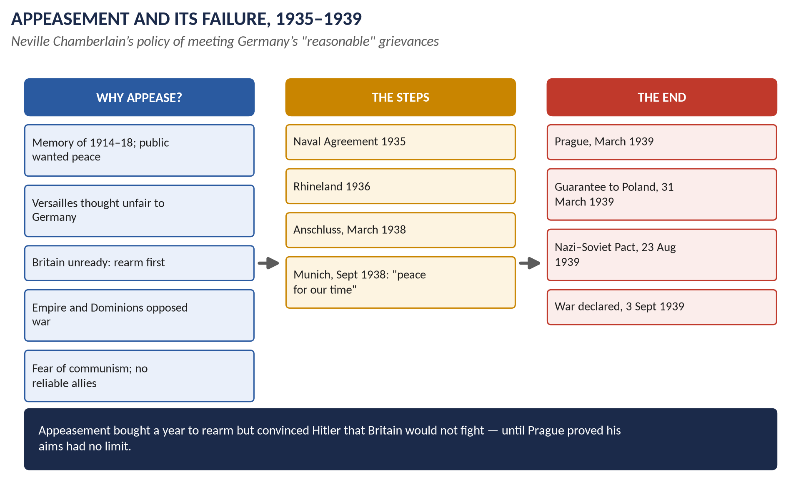
Figure 9 · Appeasement and its failure.
- Abyssinia (1935–36): partial sanctions; the Hoare–Laval Pact (December 1935) — Hoare resigned.
- The Rhineland (7 March 1936): German troops re-entered; Britain did nothing — "the Germans are only going into their own back garden" (Lord Lothian).
- The Spanish Civil War (1936–39): Britain led a non-intervention policy, while Germany and Italy helped Franco.
- Neville Chamberlain became PM in May 1937 and made appeasement an active policy: seek out Germany's "reasonable" grievances and settle them.
- Lord Halifax's visit to Hitler (November 1937); Anthony Eden resigned as Foreign Secretary (February 1938).
- The Anschluss (12 March 1938): Germany annexed Austria; Britain protested only.
- Czechoslovakia: Hitler demanded the Sudetenland (3 million German speakers). Chamberlain flew to meet Hitler at Berchtesgaden (15 September) and Godesberg (22 September). He said on the radio: "How horrible, fantastic, incredible it is that we should be digging trenches … because of a quarrel in a far-away country between people of whom we know nothing."
- The Munich Agreement (29–30 September 1938): Britain, France, Germany and Italy agreed that Germany should take the Sudetenland; Czechoslovakia was not consulted. Chamberlain returned waving a paper signed by Hitler: "peace for our time". Churchill: "a total and unmitigated defeat".

8.6 Phase 5 · 1939: from appeasement to war
- 15 March 1939: Germany occupied Prague and the rest of the Czech lands — proof that Hitler's aims went beyond Germans. Appeasement was dead.
- 31 March 1939: Britain and France guaranteed Poland; guarantees to Romania and Greece followed (April).
- April 1939: conscription (the Military Training Act) — the first in peacetime.
- Slow talks with the USSR failed; the Nazi–Soviet Pact (23 August 1939) shocked the world.
- 25 August: the Anglo-Polish Agreement.
- 1 September 1939: Germany invaded Poland. 3 September: Britain's ultimatum expired and Chamberlain announced on the radio that "this country is at war with Germany".

8.7 Rearmament
- 1932: the Ten Year Rule abandoned.
- 1934: RAF expansion began; the Defence Requirements Committee named Germany as the "ultimate potential enemy".
- 1935 Defence White Paper; 1936 the "shadow factories" (car firms prepared to build aircraft).
- Priority to the RAF: the Spitfire and Hurricane fighters; the radar chain along the coast (from 1936–37).
- Defence spending roughly quadrupled between 1935 and 1939.
- Argument: Chamberlain's supporters say appeasement bought time to rearm, which won the Battle of Britain (1940); critics say Germany rearmed faster in the same year.

8.8 Was appeasement right? — the debate
Arguments for appeasement | Arguments against
Public opinion wanted peace (Peace Ballot; East Fulham by-election 1933) | It encouraged Hitler: each success made him bolder
Versailles was unfair — Germany had real grievances | It sacrificed Czechoslovakia, with its strong army and fortresses
Britain was not ready — rearmament needed time | It ignored Hitler's own words (Mein Kampf)
The Dominions and the USA would not support war in 1938 | It alienated the USSR, leading to the Nazi–Soviet Pact
Economic weakness: war would ruin Britain | Germany gained more from the extra year (Czech arms, Škoda works)
Fear of communism; Germany as a barrier | It destroyed the League and collective security

Historians: "Cato", Guilty Men (1940) — Chamberlain and colleagues were guilty of weakness; A. J. P. Taylor (The Origins of the Second World War, 1961) — Hitler was an opportunist, appeasement understandable; R. A. C. Parker (Chamberlain and Appeasement, 1993) — Chamberlain had alternatives (a Grand Alliance with France and the USSR) and rejected them.
WHAT THE EXAMINER HAS ASKED · Where Chapters 6–8 have been asked
2015 P-II Q8 (British foreign policy 1919–39) · 2020 Q7 (the League of Nations). MCQs 2024: Versailles signed on 28 June 1919; two PMs in the war (Asquith and Lloyd George); 2025: Britain's policy towards Nazi Germany was appeasement; 2026: appeasement is linked with Neville Chamberlain.

Chapter 9 · Britain at Home Between the Wars, 1918–1939

9.1 The Lloyd George coalition (1918–1922)
- Promises: "a fit country for heroes to live in" (November 1918).
- Reforms: the Addison Housing Act (1919, about 213,000 council houses); unemployment insurance extended to most workers (1920); the Ministry of Health (1919); the Fisher Education Act (1918).
- The Irish settlement: the Anglo-Irish Treaty (December 1921) — the Irish Free State (1922).
- The slump (from 1920–21); the "Geddes Axe" (1922) cut spending on housing, education and the forces.
- The honours scandal (selling peerages) and Chanak (1922) → the Carlton Club revolt; Lloyd George fell and never held office again.

9.2 The 1920s
- Bonar Law (1922–23), Stanley Baldwin (1923–24), the first Labour government (1924), Baldwin again (1924–29).
- The gold standard (April 1925): Churchill as Chancellor returned the pound to gold at the pre-war rate ($4.86) — making exports dearer (Keynes: The Economic Consequences of Mr Churchill).
- The General Strike (4–12 May 1926):
  - Causes: the coal industry's decline; mine-owners demanded longer hours and lower wages; the Samuel Commission (1926) recommended wage cuts; "Not a penny off the pay, not a minute on the day" (A. J. Cook).
  - Events: the TUC called out about 1.7 million workers (transport, printing, docks, heavy industry). The government, prepared since "Red Friday" (1925), used volunteers, troops and its own newspaper (the British Gazette, edited by Churchill) and the new BBC. After nine days the TUC called it off; the miners stayed out until November and were forced to accept longer hours and lower pay.
  - Results: the Trade Disputes Act (1927) made general strikes illegal and made union members "contract in" to the political levy; union membership fell; unions turned to moderation and to Labour.
- Other reforms: widows' and old-age contributory pensions (1925, Neville Chamberlain); the Local Government Act (1929) ended the Poor Law guardians; the Equal Franchise Act (1928).

9.3 The Great Depression (1929–1933)
- The Wall Street Crash (October 1929) in New York led to a world slump; world trade fell by about a third.
- In Britain: exports halved; unemployment rose to almost 3 million (about 22–23 per cent of insured workers) in 1932–33.
- The 1931 crisis: the May Committee (July 1931) forecast a budget deficit of about £120 million and demanded cuts, including unemployment pay; foreign bankers withdrew gold; the Labour cabinet split. On 24 August 1931 MacDonald formed a National Government with Baldwin's Conservatives and the Liberals. It cut unemployment benefit by 10 per cent and public salaries; sailors mutinied at Invergordon (September); Britain left the gold standard (21 September 1931). The National Government won a huge victory (October 1931: 554 seats).
- Recovery measures: cheap money (interest rates cut to 2 per cent, 1932); the Import Duties Act (1932) ended free trade; imperial preference at the Ottawa Conference (1932); the means test for the long-term unemployed (hated); the Special Areas Act (1934).

9.4 Two Britains
- The depressed areas — South Wales, Clydeside, Tyneside, Lancashire — depended on coal, cotton, shipbuilding and steel. In Jarrow, "the town that was murdered", unemployment reached about 70 per cent after the shipyard closed; 200 men marched to London in the Jarrow Crusade (October 1936).
- The prosperous south and Midlands: new industries (cars — Morris, Austin; electrical goods; chemicals; aircraft); a housing boom (about 3 million houses built in the 1930s); cinemas, radios, holidays; for those in work, real wages rose.
- Extremism: Oswald Mosley's British Union of Fascists (1932); the Battle of Cable Street (October 1936); the Public Order Act (1936). The Communist Party remained small.

9.5 The abdication crisis (1936)
- George V died on 20 January 1936; his son became Edward VIII.
- Edward wished to marry Wallis Simpson, an American twice divorced. The Church of England did not then allow remarriage after divorce while a former spouse lived; Baldwin, the cabinet and the Dominion governments opposed the marriage; a "morganatic" marriage (she would not be queen) was rejected.
- Edward signed the Instrument of Abdication on 10 December 1936; Parliament passed the Abdication Act and he announced his abdication in a radio broadcast on 11 December 1936: "I have found it impossible to carry the heavy burden of responsibility … without the help and support of the woman I love." He became the Duke of Windsor.
- His brother became George VI (1936–52), father of Elizabeth II. The monarchy survived with its reputation restored.

9.6 Neville Chamberlain as PM (1937–1940)
A capable social reformer (as Minister of Health in the 1920s) who became known mainly for appeasement (Chapter 8). He resigned in May 1940, after the failed Norway campaign, and Churchill became Prime Minister (Topic 8).

Chapter 10 · The Legacy — to 2026
Theme | What happened later
The First World War | The centenary (2014–18) was marked nationally — the ceramic poppies at the Tower of London (2014); Armistice Day remains a national ritual.
The Labour Party | Governments of 1945–51, 1964–70, 1974–79, 1997–2010; Keir Starmer's victory on 4 July 2024 (411 seats).
The Liberals | Revived as the Liberal Democrats (1988); in coalition with the Conservatives (2010–15); 72 seats in 2024 — their best since the 1920s.
The League | Replaced by the United Nations (1945); the ILO still exists.
Versailles and appeasement | "Munich" became a byword for weakness; leaders invoked it over Suez (1956), Iraq (1990) and Russia's aggression against Ukraine (2014, 2022).
The welfare state | Built on the Liberal reforms and Beveridge; the NHS (1948) is still a central political issue.
The Middle East | The wartime promises (Balfour, Sykes–Picot) shaped the conflicts of Palestine and Israel down to the present.

Part Four — Historians and Quotations
Historian | The view to quote
George Dangerfield, The Strange Death of Liberal England (1935) | Liberal England was dying before 1914.
Trevor Wilson, The Downfall of the Liberal Party (1966) | The war was the "rampant omnibus" that killed the Liberals.
Ross McKibbin, The Evolution of the Labour Party (1974) | Class and the 1918 franchise, not the war alone, made Labour.
Henry Pelling, Origins of the Labour Party (1954) | The unions, driven by Taff Vale, created the party.
Arthur Marwick, The Deluge (1965) | War as a cause of social change — women, class, the state.
Fritz Fischer (1961); Christopher Clark (2012); Niall Ferguson (1998) | German aims; shared responsibility; Britain's mistake.
J. M. Keynes, The Economic Consequences of the Peace (1919) | Versailles a "Carthaginian peace".
Margaret MacMillan, Peacemakers (2001) | The peacemakers did better than their critics admit.
Zara Steiner, The Lights that Failed (2005) | The 1920s' hopes and their collapse.
"Cato", Guilty Men (1940); A. J. P. Taylor (1961); R. A. C. Parker (1993) | Appeasement as guilt, as understandable, as a choice.

"The lamps are going out all over Europe; we shall not see them lit again in our lifetime." — Sir Edward Grey, 3 August 1914
"What is our task? To make Britain a fit country for heroes to live in." — Lloyd George, November 1918
"This is not peace. It is an armistice for twenty years." — Marshal Foch, 1919
"I believe it is peace for our time." — Neville Chamberlain, 30 September 1938
"We have sustained a total and unmitigated defeat." — Churchill on Munich, 5 October 1938

Part Five — The Examiner's Record
Paper | The question as set | Family | Type
2015 · Q8 · Paper II | Describe and critically analyze the foreign policy of England from 1919 to 1939. | Inter-war foreign policy and the League | Policy analysis
2020 · Q7 · Section B | What do you know about the League of Nations? Explain the work of the League. What were the causes of its failure? | Inter-war foreign policy and the League | Causes / results
2021 · Q4 · Section A | Provide a detailed account of the causes of World War I and its effects on the social and economic aspects of Britain. | The First World War and its effects | Causes / results
2021 · Q5 · Section A | What is the Edwardian era? Elucidate the rise and significance of the Labour Movement in the Edwardian era. | Edwardian era and the rise of Labour | Describe / account
2022 · Q4 · Section A | Discuss the rise of the Labour Party in Britain and enumerate the achievements of this party. | Edwardian era and the rise of Labour | Describe / account
2022 · Q8(a) · Section B | Short note: Lord Kitchener | The First World War and its effects | Short note
2023 · Q5 · Section A | According to Rudyard Kipling, 'however the world pretends to divide itself, there are only two divisions in the world today — human beings and Germans.' In the light of this statement, was British policy in the First World War justified or not? Comment. | The First World War and its effects | Quotation / claim
2026 · Q5 · Section A | Critically evaluate the effects of World War I on British social structure, industrial relations, and the polity, highlighting the ways in which the war accelerated the decline of the Liberal Party and paved the way for Labour's rise to power. | The First World War and its effects | Impact / significance

WHAT THE EXAMINER HAS ASKED · The pattern
Labour is asked as the Edwardian Labour movement (2021) and the rise and achievements of the party (2022). The First World War comes as causes and social-economic effects (2021), a quotation on British policy (Kipling, 2023) and the effects on society, industry and politics with the Liberal decline (2026); Kitchener as a short note (2022). Between the wars: foreign policy 1919–39 (2015) and the League (2020). Never yet set as full questions: the Liberal reforms, the constitutional crisis of 1909–11, the peace settlement, the General Strike, the Great Depression, appeasement on its own.

Part Six — The One-Liner Bank
HOW TO USE THIS · How to use the one-liners
Cover the answer after the arrow and say it aloud. 120 questions; bold words are the ones examiners test. The past MCQs are solved in T7QA.

One-liners · The Edwardian era and the Liberal reforms
1. Which monarch gave the Edwardian era its name? → Edward VII (1901–10).
2. When did Queen Victoria die? → 22 January 1901.
3. Whose study of York (1901) found about 28 per cent in poverty? → Seebohm Rowntree.
4. Who surveyed poverty in London? → Charles Booth.
5. Which Conservative PM passed the Education Act of 1902? → Arthur Balfour.
6. Who launched tariff reform in 1903? → Joseph Chamberlain.
7. Which 1901 judgment let unions be sued for strike losses? → Taff Vale.
8. How many seats did the Liberals win in 1906? → 397 (a landslide).
9. How many Labour MPs were elected in 1906? → 29.
10. Which 1906 Act reversed Taff Vale? → The Trade Disputes Act.
11. What did the 1906 Education (Provision of Meals) Act allow? → Free school meals.
12. What was the Children's Act (1908) nicknamed? → "The Children's Charter".
13. What did the Old Age Pensions Act (1908) give? → 5 shillings a week at 70.
14. Who set up Labour Exchanges (1909)? → Winston Churchill (with Beveridge).
15. Which 1909 Act set minimum wages in sweated trades? → The Trade Boards Act.
16. Whose 1909 budget was called the "People's Budget"? → Lloyd George's.
17. Which house rejected it? → The House of Lords (November 1909).
18. What did the Parliament Act 1911 do? → Ended the Lords' veto (two-year delay; no delay to money bills).
19. When were MPs first paid, and how much? → 1911, £400 a year.
20. What did the National Insurance Act 1911 cover? → Health and unemployment.
21. What was National Insurance's slogan? → "Ninepence for fourpence".
22. Who wrote The Strange Death of Liberal England? → George Dangerfield (1935).
23. Which suffragette died at the Derby in 1913? → Emily Wilding Davison.
24. What was the 1913 "Cat and Mouse Act"? → Released hunger-strikers and re-arrested them.
25. Where did troops face strikers in 1910? → Tonypandy (South Wales).
26. Who led the Ulster Unionists against Home Rule? → Sir Edward Carson.
27. What was the Curragh incident (1914)? → Army officers refusing to act against Ulster.
28. Which battleship of 1906 began a new naval race? → HMS Dreadnought.
29. What did the public chant in 1909? → "We want eight and we won't wait."
30. Which crisis of 1911 involved the gunboat Panther? → Agadir (Second Moroccan Crisis).
31. Who reformed the army (1906–12), creating the BEF? → Richard Haldane.

One-liners · The rise of Labour
32. When was the London Dock Strike? → 1889.
33. Who was the first independent Labour MP (1892)? → Keir Hardie.
34. Where and when was the ILP founded? → Bradford, 1893.
35. When was the Labour Representation Committee founded? → 27 February 1900.
36. Who was its first secretary? → Ramsay MacDonald.
37. What was the Gladstone–MacDonald pact (1903)? → Liberals and Labour did not fight each other in about 30 seats.
38. When did the LRC rename itself the Labour Party? → 1906.
39. What did the Osborne judgment (1909) forbid? → Unions using funds for politics.
40. Which Act of 1913 restored the political levy? → The Trade Union Act.
41. Who led Labour during the war? → Arthur Henderson.
42. Which clause of Labour's 1918 constitution called for common ownership? → Clause IV.
43. Who drafted it with Henderson? → Sidney Webb.
44. When did Labour become the official opposition? → 1922.
45. When was the first Labour government? → 1924 (January–November).
46. Which forged letter harmed Labour in the 1924 election? → The Zinoviev letter.
47. When was Labour first the largest party? → 1929.
48. Why did MacDonald form a National Government in 1931? → The cabinet split over cuts in unemployment benefit.
49. How many seats did Labour win in 1945? → 393.
50. Who created the NHS (1948)? → Aneurin Bevan.
51. Which report of 1942 planned the welfare state? → The Beveridge Report.
52. How many seats did Labour win on 4 July 2024? → 411 (Keir Starmer).

One-liners · The First World War
53. Who was assassinated at Sarajevo on 28 June 1914? → Archduke Franz Ferdinand.
54. Who fired the shots? → Gavrilo Princip.
55. What was Germany's promise to Austria called? → The "blank cheque".
56. What was Germany's plan to attack France through Belgium? → The Schlieffen Plan.
57. What does M·A·I·N stand for? → Militarism, Alliances, Imperialism, Nationalism.
58. Which treaty (1839) guaranteed Belgian neutrality? → The Treaty of London.
59. What did Bethmann Hollweg call it? → "A scrap of paper".
60. When did Britain declare war on Germany? → 4 August 1914.
61. Who said "the lamps are going out all over Europe"? → Sir Edward Grey.
62. Which Act of 8 August 1914 gave the government wide powers? → DORA (Defence of the Realm Act).
63. Which 1915 campaign against Turkey failed? → Gallipoli.
64. What crisis of May 1915 led to a coalition? → The shell crisis.
65. When did conscription begin? → January 1916 (Military Service Act).
66. What was the only great naval battle (31 May 1916)? → Jutland.
67. How many British casualties on the Somme's first day? → About 57,000 (about 19,000 dead).
68. How many PMs led Britain in the war? → Two — Asquith and Lloyd George.
69. When did Lloyd George become PM? → December 1916.
70. When did the USA join the war? → April 1917.
71. What did the Balfour Declaration (1917) promise? → A Jewish national home in Palestine.
72. When was the Armistice? → 11 a.m., 11 November 1918.
73. About how many UK servicemen died? → About 750,000.
74. What name did the royal family adopt in 1917? → Windsor.
75. Who was Secretary of State for War in 1914? → Lord Kitchener.
76. Which battle of 1898 made Kitchener famous? → Omdurman.
77. What was Kitchener's famous poster? → "Your Country Needs You".
78. How did Kitchener die? → HMS Hampshire struck a mine off Orkney, 5 June 1916.
79. Which Viceroy resigned after clashing with Kitchener (1905)? → Lord Curzon.
80. What did Kipling say were the only two divisions in the world? → "Human beings and Germans".

One-liners · Effects of the war
81. By how much did the national debt grow in the war? → About eleven-fold (£650m → over £7bn).
82. What happened to income tax? → 1s 2d → 6s in the pound.
83. How did union membership change (1914–20)? → 4.1 million → 8.3 million.
84. What was dilution? → Unskilled workers doing skilled jobs.
85. Where was "Red Clydeside"? → Glasgow.
86. Which 1918 Act gave votes to women over 30? → The Representation of the People Act.
87. How did the electorate change in 1918? → About 7.7m → 21.4m.
88. What was the coupon election? → The December 1918 election; Lloyd George's candidates got a letter of support.
89. Which 1919 Act opened professions to women? → The Sex Disqualification (Removal) Act.
90. Which Act of 1919 began council housing? → The Addison Housing Act.
91. Who described the war as a "rampant omnibus" killing the Liberals? → Trevor Wilson.
92. When was Black Friday? → April 1921 (the Triple Alliance collapsed).

One-liners · Peace and the League
93. When was the Treaty of Versailles signed? → 28 June 1919.
94. Who were the Big Three? → Wilson, Clemenceau, Lloyd George.
95. Which article was the "War Guilt Clause"? → Article 231.
96. What were reparations fixed at in 1921? → 132 billion gold marks (about £6.6bn).
97. How large could Germany's army be? → 100,000 men.
98. Which treaty dealt with Austria? → St Germain (1919).
99. Which treaty dealt with Hungary? → Trianon (1920).
100. Who called Versailles a "Carthaginian peace"? → J. M. Keynes.
101. When did the League of Nations begin? → 10 January 1920.
102. Where was its headquarters? → Geneva.
103. Which great power never joined? → The USA.
104. Who created passports for refugees? → Fridtjof Nansen.
105. Which 1932 report condemned Japan over Manchuria? → The Lytton Report.
106. Which secret pact of 1935 offered Italy much of Abyssinia? → The Hoare–Laval Pact.

One-liners · Between the wars
107. Which treaties of 1925 guaranteed Germany's western borders? → Locarno.
108. What was the Ten Year Rule (1919)? → Assume no major war for ten years.
109. What ratio did the Washington Treaty (1922) set? → 5 : 5 : 3 (Britain : USA : Japan).
110. Which crisis of 1922 brought down Lloyd George? → Chanak.
111. When was the General Strike? → 4–12 May 1926.
112. Who returned Britain to the gold standard (1925)? → Churchill.
113. When did Britain leave the gold standard? → 21 September 1931.
114. Which town's men marched to London in 1936? → Jarrow.
115. Who led the British Union of Fascists? → Oswald Mosley.
116. When did Edward VIII announce his abdication? → 11 December 1936.
117. What was Britain's policy towards Hitler in the late 1930s called? → Appeasement.
118. Which PM is most associated with appeasement? → Neville Chamberlain.
119. When was the Munich Agreement? → 29–30 September 1938.
120. When did Britain declare war on Germany in 1939? → 3 September 1939.

Part Seven — Revision Sheet · Topic 7: Edwardian Britain, the Great War and the Road to 1939
HOW TO USE THIS · How to use this sheet
Complete on its own for the night before the paper. Syllabus Heads X–XI. Asked: Edwardian Labour movement (2021), Labour's rise and achievements (2022), WWI causes and effects (2021), Kipling and British policy (2023), WWI effects and the Liberal decline (2026), Kitchener (2022 sn), foreign policy 1919–39 (2015), the League (2020).

R7.1 The Edwardian era
Edward VII 1901–10 (loosely to 1914): wealth and poverty (Rowntree 1901: ~28% poor in York; Booth); Boer War recruits unfit. Balfour (1902–05): Education Act 1902; Taff Vale 1901 (£23,000); tariff reform 1903 (Chamberlain) splits Conservatives. 1906: Liberals 397, Labour 29. Crises 1910–14 (Dangerfield): Lords, suffragettes (WSPU 1903; Davison 1913; Cat and Mouse), Great Unrest (Tonypandy 1910; dock and rail 1911; coal 1912; Triple Alliance 1914), Ulster (Carson, Covenant, Curragh 1914). Foreign: ententes 1904, 1907; Dreadnought 1906; Morocco 1905, Agadir 1911; military talks; naval agreement 1912; Haldane (BEF, Territorials 1908).

R7.2 The Liberal reforms 1906–14
Why: poverty evidence; New Liberalism (Green, Hobhouse); national efficiency; Labour threat; Lloyd George and Churchill. Children: school meals 1906; medical inspection 1907; Children's Act 1908. Old: pensions 1908 (5s at 70). Workers: Trade Disputes 1906; Labour Exchanges 1909; Trade Boards 1909. People's Budget 1909 (supertax, land taxes) → Lords reject → two elections 1910 → Parliament Act 1911; MPs paid £400. National Insurance 1911 (health 4d+3d+2d; unemployment 7s for 15 weeks). Judgement: foundations of the welfare state, but limited.

R7.3 The Labour movement and party
Roots: New Unionism (match girls 1888, Dock Strike 1889); SDF 1881, Fabians 1884, ILP 1893; Keir Hardie 1892. LRC 27 Feb 1900 (MacDonald). Rise: Taff Vale → unions join; pact 1903; 29 MPs 1906 → Labour Party; Osborne 1909 → Trade Union Act 1913; 42 MPs 1910; unions ~4m by 1914. Significance: independent working-class voice; pushed Liberal reforms; class politics — but still junior before 1914. War: Henderson in cabinet; 1918 constitution, Clause IV; electorate tripled. Interwar: opposition 1922; govt 1924 (Wheatley housing; Zinoviev); largest party 1929; 1931 split — National Govt; 52 seats. Achievements: 1945–51 (393 seats) — NHS 1948, National Insurance 1946, nationalisation, housing, India 1947, NATO 1949; Wilson (Open University, death penalty abolished, equality laws); Blair (minimum wage, devolution, Good Friday, HRA); Starmer 2024 (411 seats).

R7.4 Causes of the First World War
M·A·I·N: militarism (Schlieffen; naval race), alliances (Triple Alliance 1882 v Triple Entente 1894–1907), imperialism, nationalism (Serbia, Pan-Slavism, Alsace-Lorraine). Crises: Morocco 1905, Bosnia 1908, Agadir 1911, Balkan Wars 1912–13. July 1914: Sarajevo 28 June; blank cheque; ultimatum 23 July; Austria v Serbia 28 July; Russia mobilises; Germany v Russia 1 Aug, v France 3 Aug; Belgium invaded; Britain 4 Aug. Why Britain: Belgium (1839, "scrap of paper"); France (talks, 1912 naval deal); balance of power; German navy. Historians: Fischer, Taylor, Ferguson, Clark.

R7.5 The war and Kitchener
Mons, Marne, Ypres 1914; Gallipoli 1915; shell crisis → coalition May 1915; conscription Jan 1916; Jutland 31 May 1916; Somme 1 July 1916 (57,470 casualties day one); Lloyd George PM Dec 1916; U-boats and convoys 1917; USA April 1917; Passchendaele; Balfour Declaration; Hundred Days; Armistice 11 Nov 1918. Two wartime PMs: Asquith, Lloyd George. Kitchener: Omdurman 1898, Fashoda, Boer War (blockhouses, camps), C-in-C India (Curzon), Egypt 1911–14; War Secretary Aug 1914; foresaw long war; "Your Country Needs You", New Armies; shell crisis; died HMS Hampshire 5 June 1916. Justified? Entry for Belgium and balance — yes; propaganda (Bryce), hatred (Kipling), blockade, secret treaties (London 1915, Sykes–Picot 1916, Balfour 1917), vengeful 1918 election — harder to justify.

R7.6 Effects on Britain
Human: ~750,000 UK dead; lost generation; flu. Economic: debt ×11; income tax 1s 2d → 6s; assets sold; US loans; lost markets; old industries slump; inflation. Social: women (munitions ~950,000; vote 1918; 1919 Act); class barriers loosened; state control; housing 1919; Fisher Act 1918. Industrial relations: unions 4.1m → 8.3m; Treasury Agreement, dilution; shop stewards; Red Clydeside; Whitley Councils; 1919 strikes; Sankey; Black Friday 1921; → General Strike. Polity: coalitions; electorate 7.7m → 21.4m; Liberal split (Asquith v LG 1916; Maurice 1918; coupon 1918); Labour's 1918 constitution, opposition 1922, govt 1924. Debate: Dangerfield (dying before) v Trevor Wilson ("rampant omnibus") v McKibbin (class and franchise).

R7.7 Peace settlement and League
Versailles 28 June 1919: Alsace-Lorraine; Polish Corridor, Danzig; colonies → mandates; Saar; Rhineland demilitarised; army 100,000, no air force, 6 battleships; Art. 231; reparations £6.6bn (1921); no Anschluss. Other treaties: St Germain, Neuilly, Trianon, Sèvres → Lausanne. Keynes "Carthaginian"; Foch "armistice for twenty years". League: 10 Jan 1920, Geneva; Assembly, Council, Secretariat, Court, ILO; successes Åland, Upper Silesia, Greece–Bulgaria 1925, Nansen, health, slavery; failures Vilna, Corfu 1923, Manchuria 1931, disarmament 1932–34, Abyssinia 1935 (Hoare–Laval). Why failed: USA absent; no army; weak sanctions; unanimity; Britain and France selfish; Depression; dictators; tied to Versailles.

R7.8 Foreign policy 1919–39
Aims: peace, empire, trade, economy (Ten Year Rule 1919–32). 1919–23: Versailles; Washington 1922 (5:5:3); Chanak 1922. 1924–29: Dawes 1924; Locarno 1925; Kellogg–Briand 1928. 1929–35: Manchuria; Disarmament Conference; Stresa; Naval Agreement 1935 (35%). 1935–38: Abyssinia; Rhineland 1936; Spain non-intervention; Chamberlain PM 1937; Anschluss Mar 1938; Munich 29–30 Sept 1938 ("peace for our time"). 1939: Prague 15 Mar; guarantee to Poland 31 Mar; conscription; Nazi–Soviet Pact 23 Aug; Poland 1 Sept; war 3 Sept. Rearmament: RAF, radar, Spitfire, shadow factories. Debate: Guilty Men v Taylor v Parker.

R7.9 At home 1918–39
Lloyd George coalition ("fit country for heroes"; Addison 1919; Geddes Axe 1922; Irish Treaty 1921); gold standard 1925; General Strike 4–12 May 1926 → Trade Disputes Act 1927; Equal Franchise 1928; Crash 1929; 1931 crisis, National Government, gold standard left; ~3m unemployed; Import Duties 1932, Ottawa; means test; Jarrow 1936; Mosley, Cable Street; abdication 11 Dec 1936 → George VI.
VERDICT · The whole topic in one sentence
Between 1901 and 1939 Britain laid the foundations of the welfare state, saw Labour rise to replace the Liberals, won a world war at a ruinous cost, and tried through the League and then appeasement to preserve a peace that the dictators destroyed.

